**Database Management System**

**Hospital Management System:**

**Statement**:

XYZ hospital is a Multi Specialty hospital that includes a number of departments, doctors, and other staff working in the hospital. Patients having different kinds of ailments come to the hospital and get checkups done from the concerned doctors. If required they are admitted in the hospital and discharged after treatment.

The aim of this case study is to design and develop a database for the hospital to maintain the records of various doctors in the hospital. It also maintains records of the regular patients, patients admitted in the hospital, the check up of patients done by the doctors and patients discharged from the hospital.

**Description**:

In the hospital, there are many departments like Orthopedic, Pathology, Emergency, Dental, Gynecology, Anesthetics, I.C.U., Blood Bank, Operation Theater, Laboratory, M.R.I., Neurology, Cardiology, Cancer Department, Corpse, etc. There is an OPD where patients come and get a card (that is, entry card of the patient) for check up from the concerned doctor. After making entry in the card, they go to the concerned doctor’s room and the doctor checks up their ailments. According to the ailments, the doctor either prescribes medicine or admits the patient in the concerned department. The patient may choose either private or general room according to his/her need. But before getting admission in the hospital, the patient has to fulfill certain formalities of the hospital like room charges, etc. After the treatment is completed, the doctor discharges the patient. Before discharging from the hospital, the patient again has to complete certain formalities of the hospital like pending payment.. Next we talk about the doctors of the hospital. There are two types of doctors in the hospital, namely, regular doctors and call on doctors. Regular doctors are those doctors who come to the hospital daily. Calls on doctors are those doctors who are called by the hospital if the concerned doctor is not available

Normalization:

Normalization is a database design technique that reduces data redundancy and eliminates undesirable characteristics like Insertion, Update and Deletion Anomalies. Normalization rules divide larger tables into smaller tables and link them using relationships. The purpose of Normalization is to eliminate redundant or repetitive data and ensure data is stored logically.

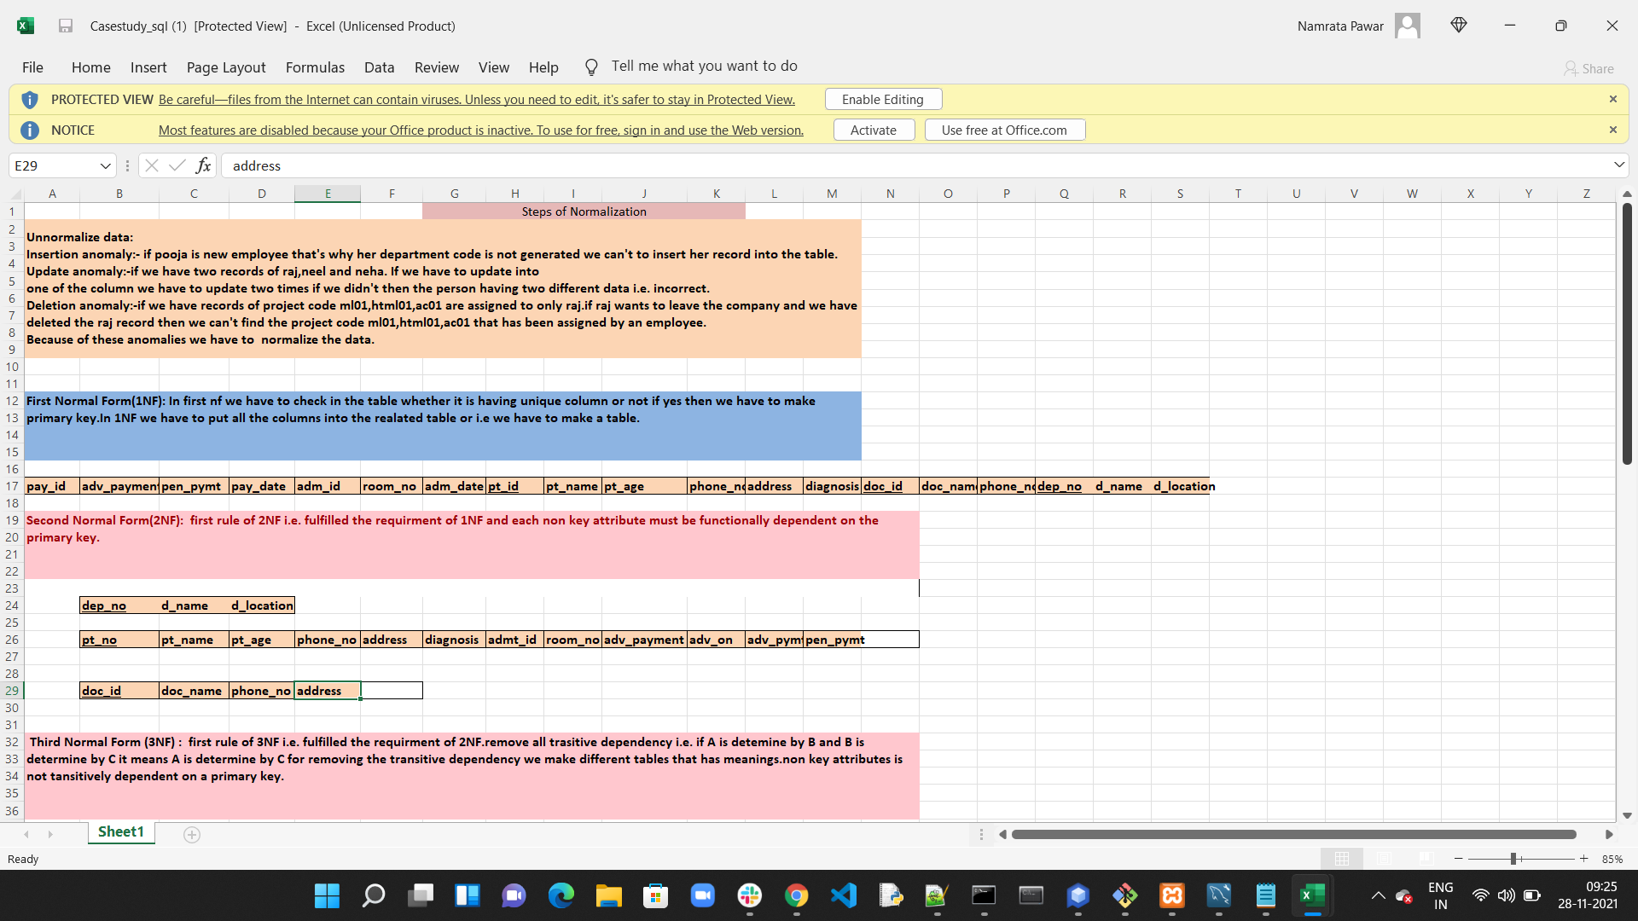

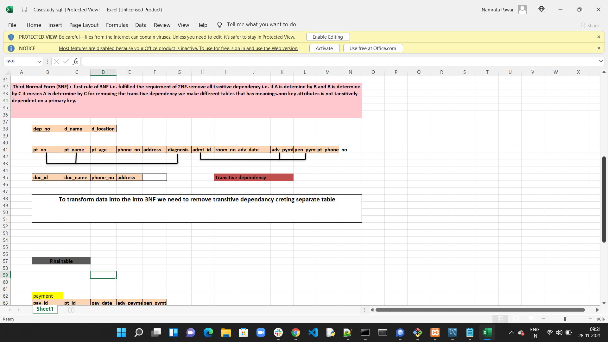

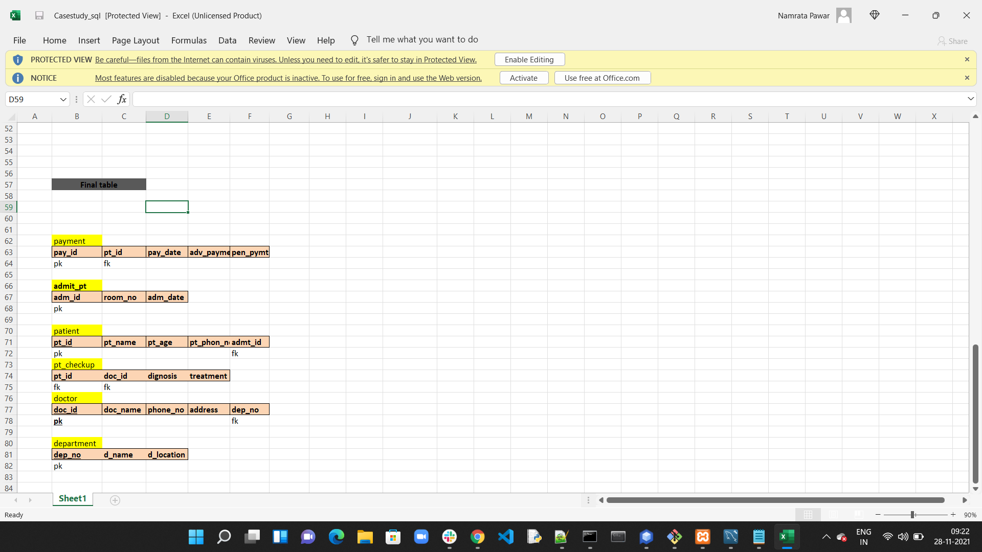

Entity Relationship Diagram:

Entity Relationship Diagram or ERD is a type of structural diagram for use in database design. It contains different symbols and connectors that visualize two important information:

The major entities within the system scope, and the inter-relationships among these entities.

Below is the ERD for Hospital management system, according to the results of normalization.

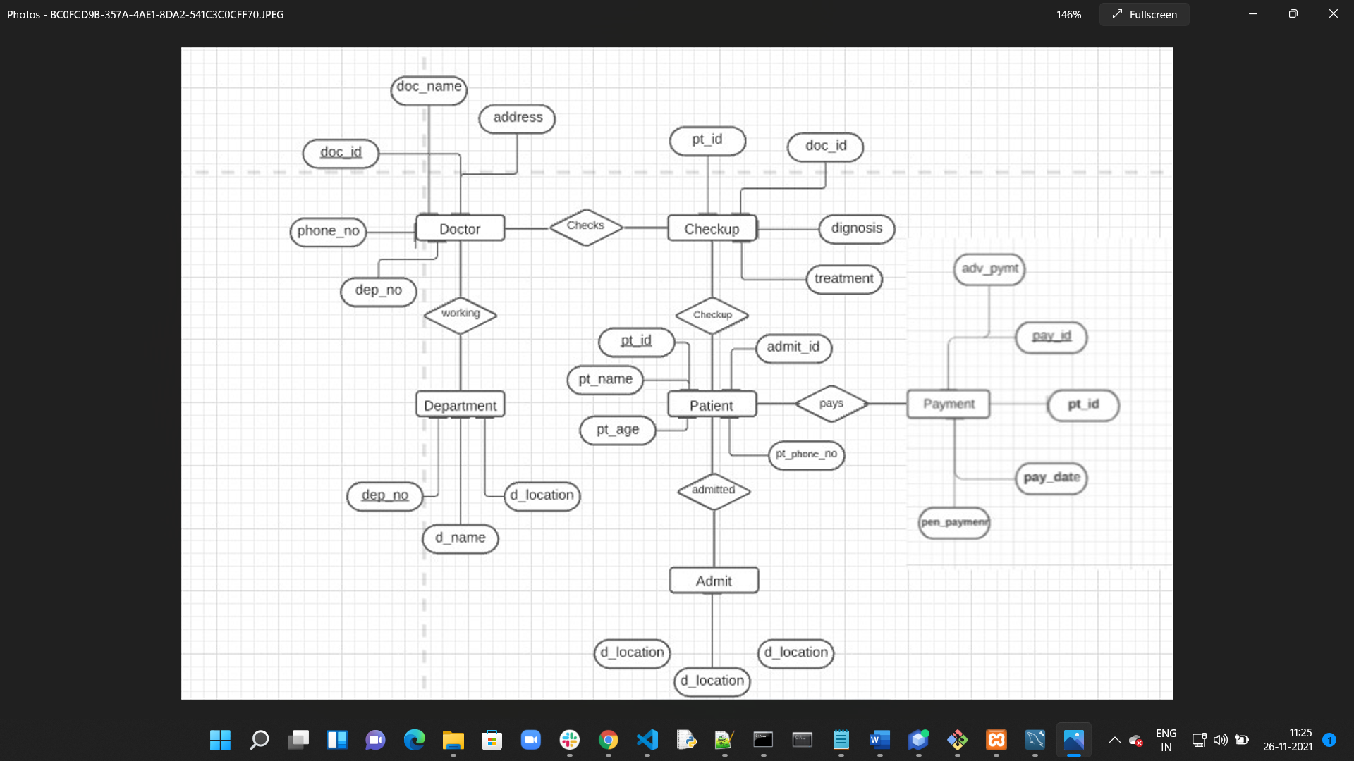

**Tables Creation and Data Dictionary**

Created Database Hospital_management:

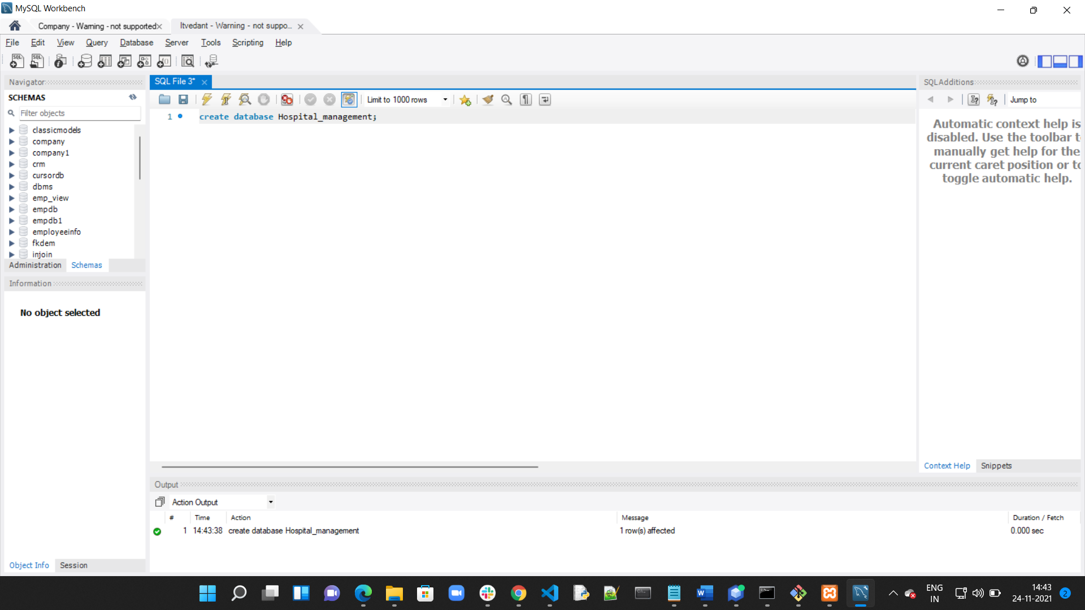

1. **Department:**

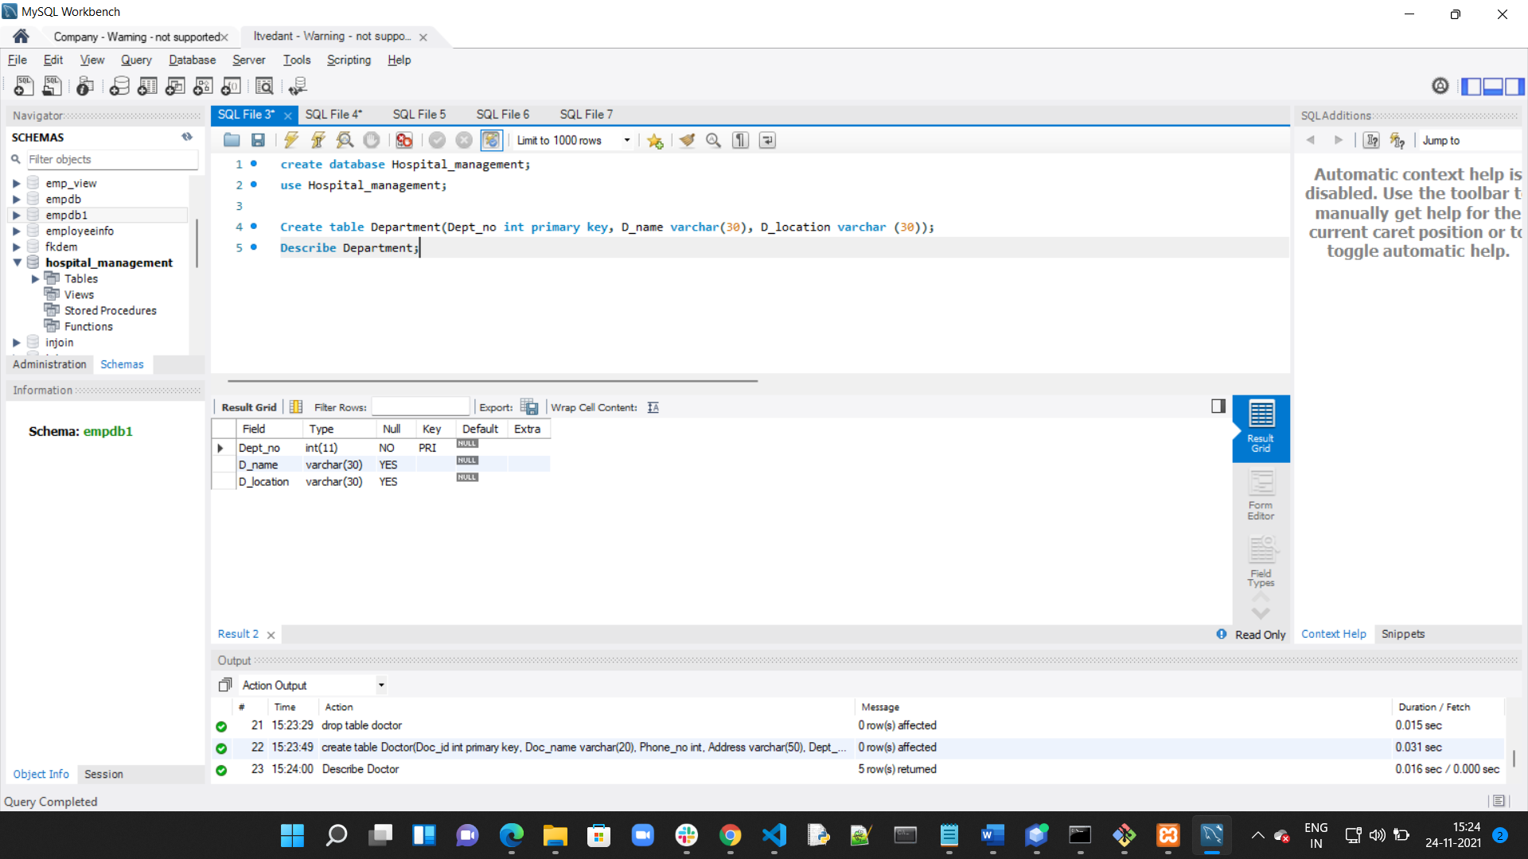

1. **Doctor:**

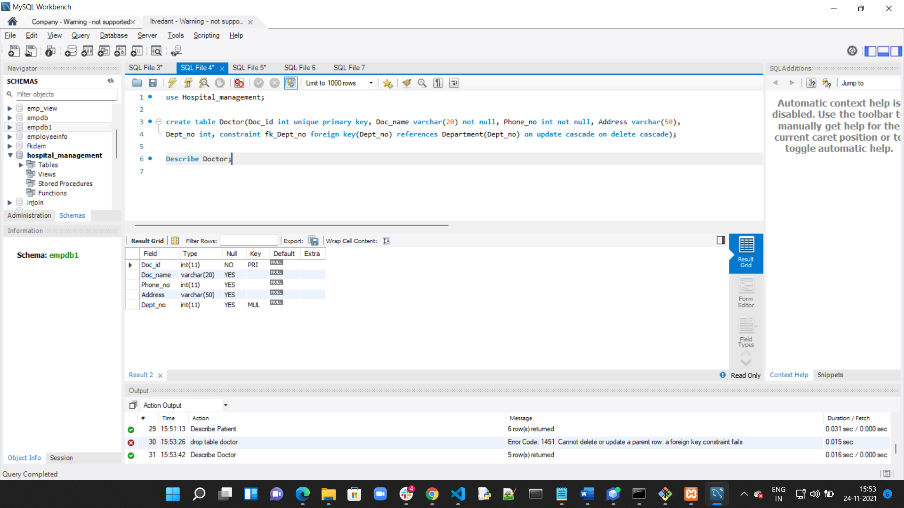

1. **Patient:**

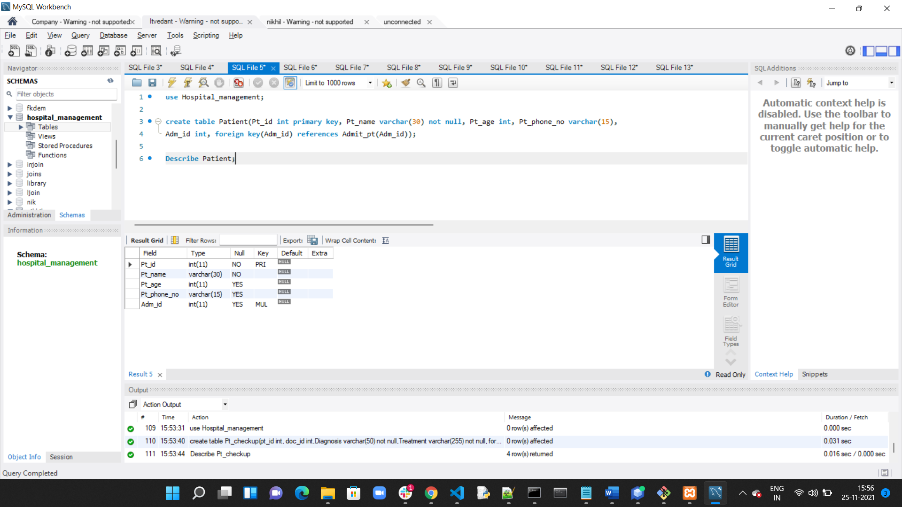

1. **Admit Patient:**

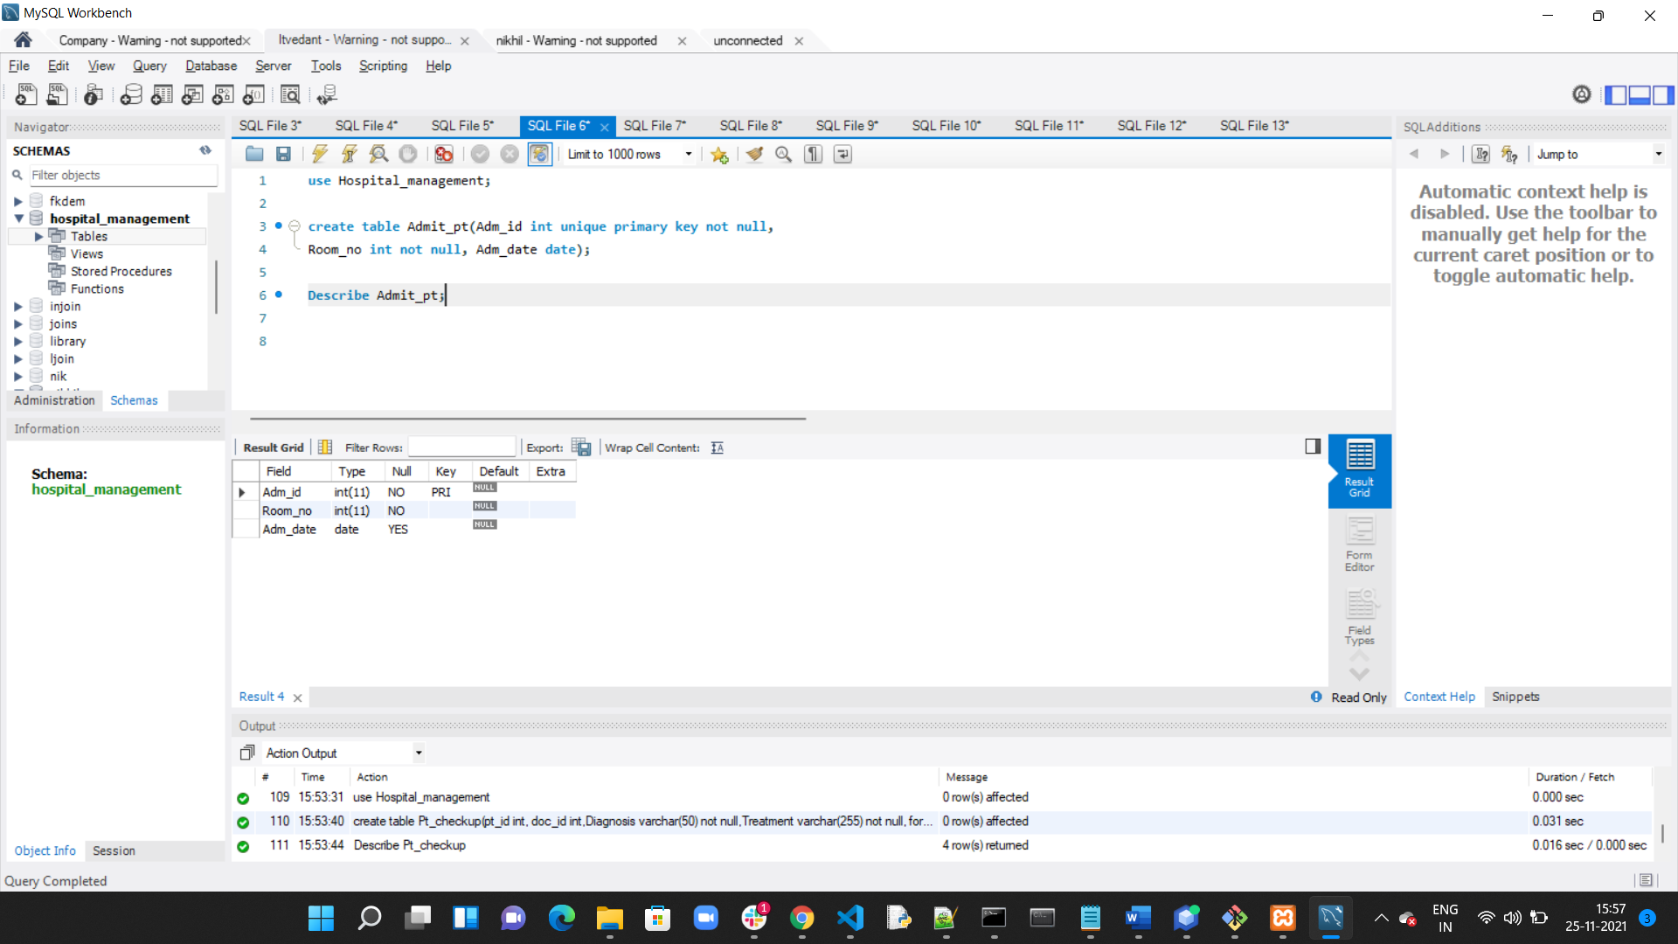

1. **Payment:**

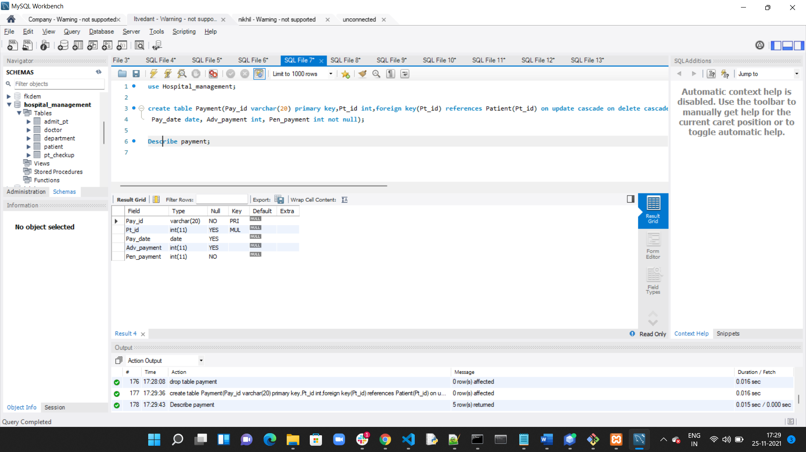

1. **Patient Checkup:**

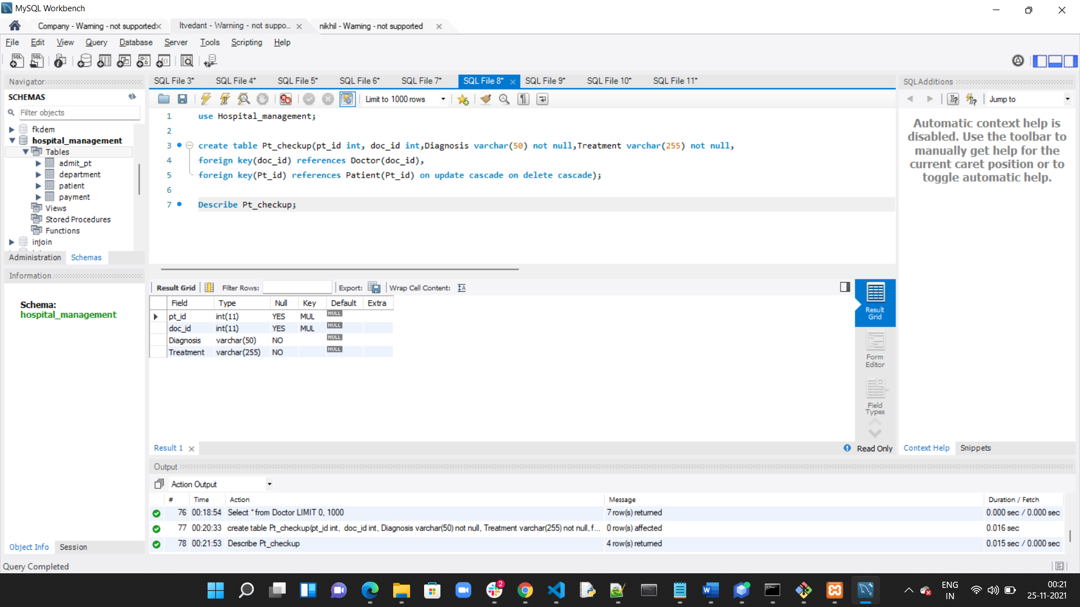

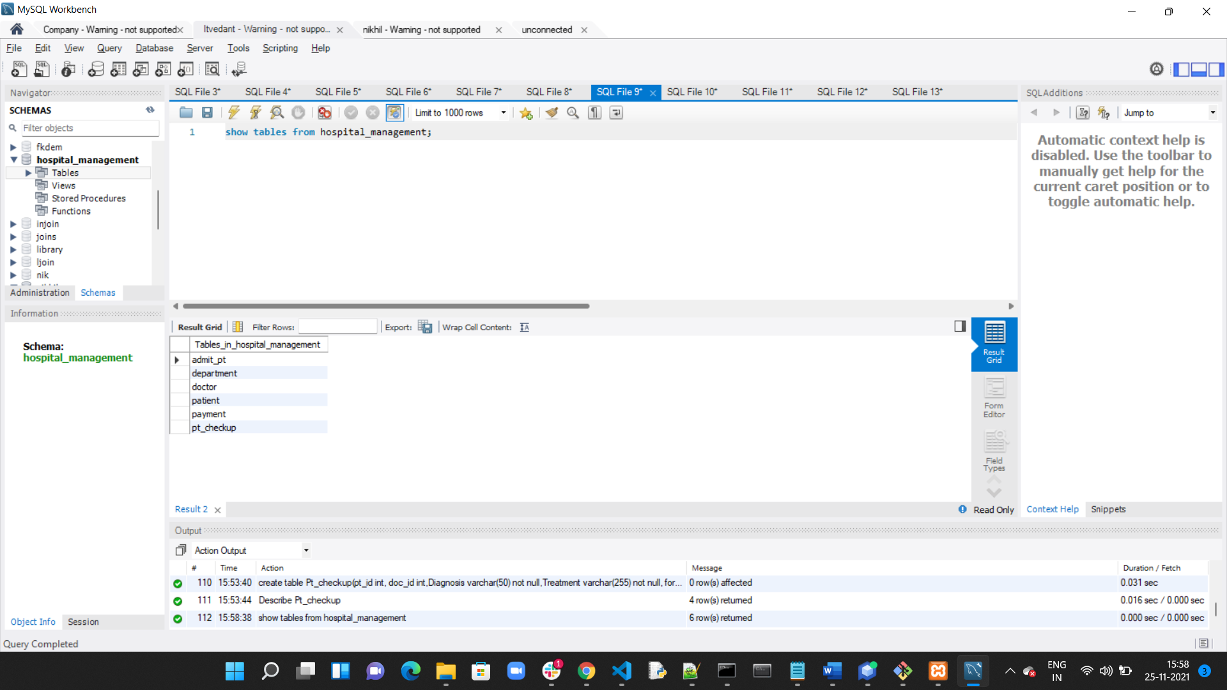

**Inserting Values in Tables**

1. **Department:**

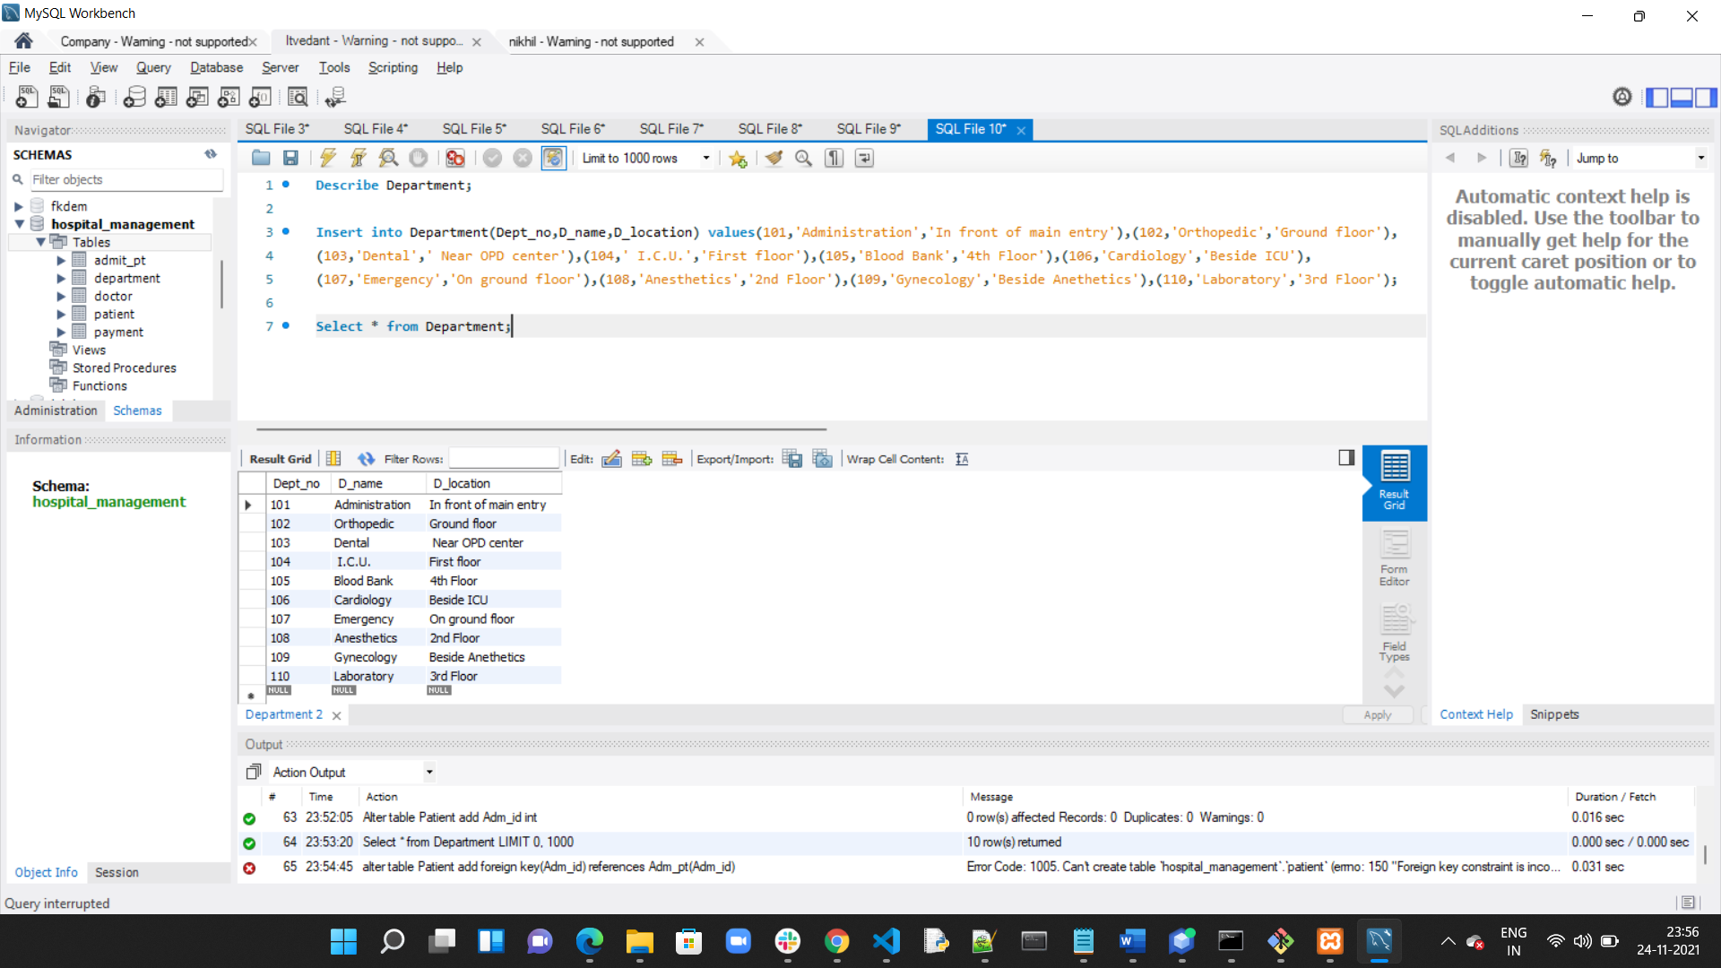

1. **Doctor:**

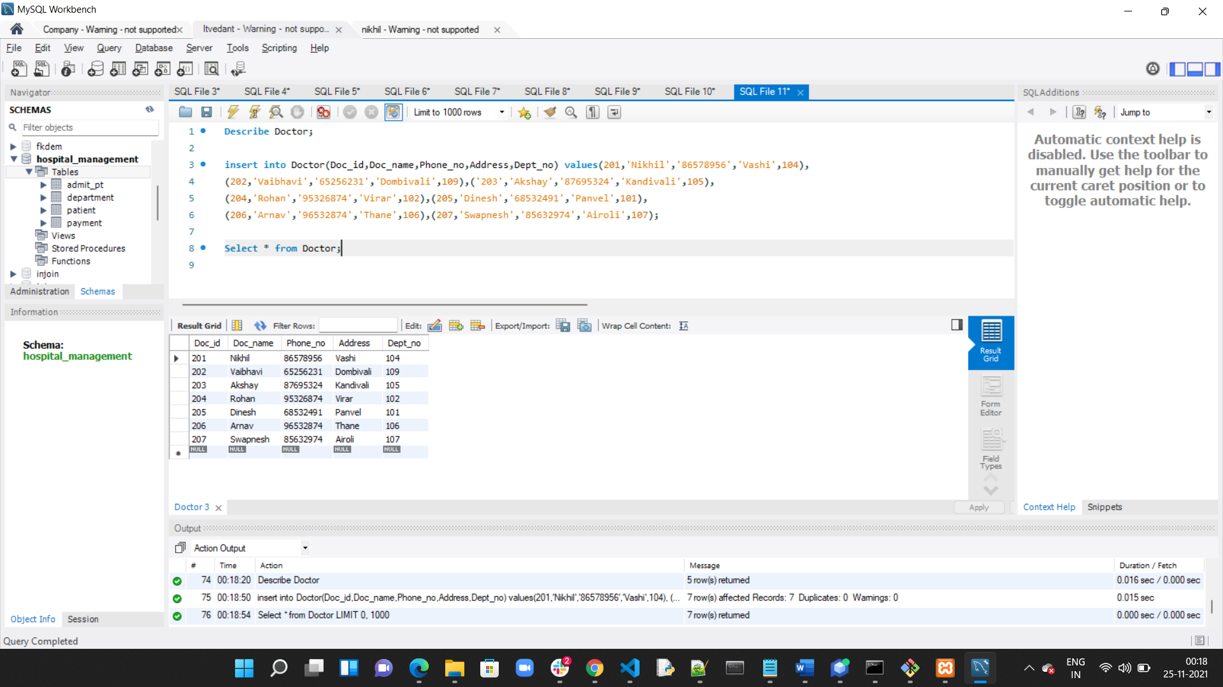

1. **Admit:**

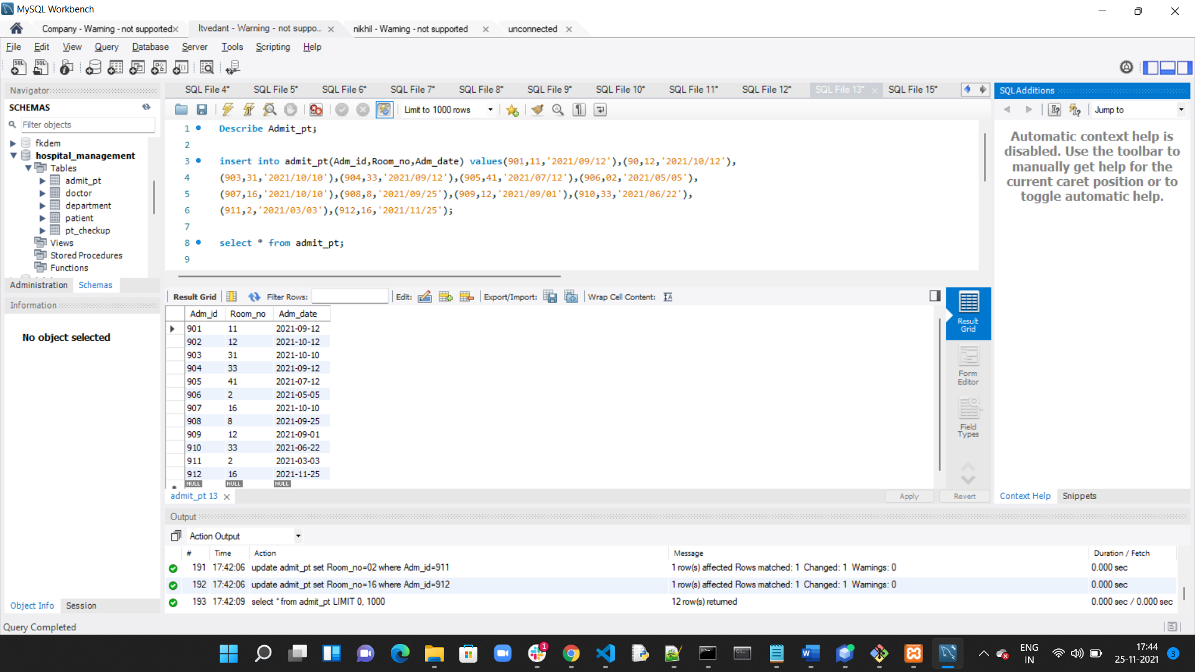

1. **Patient:**

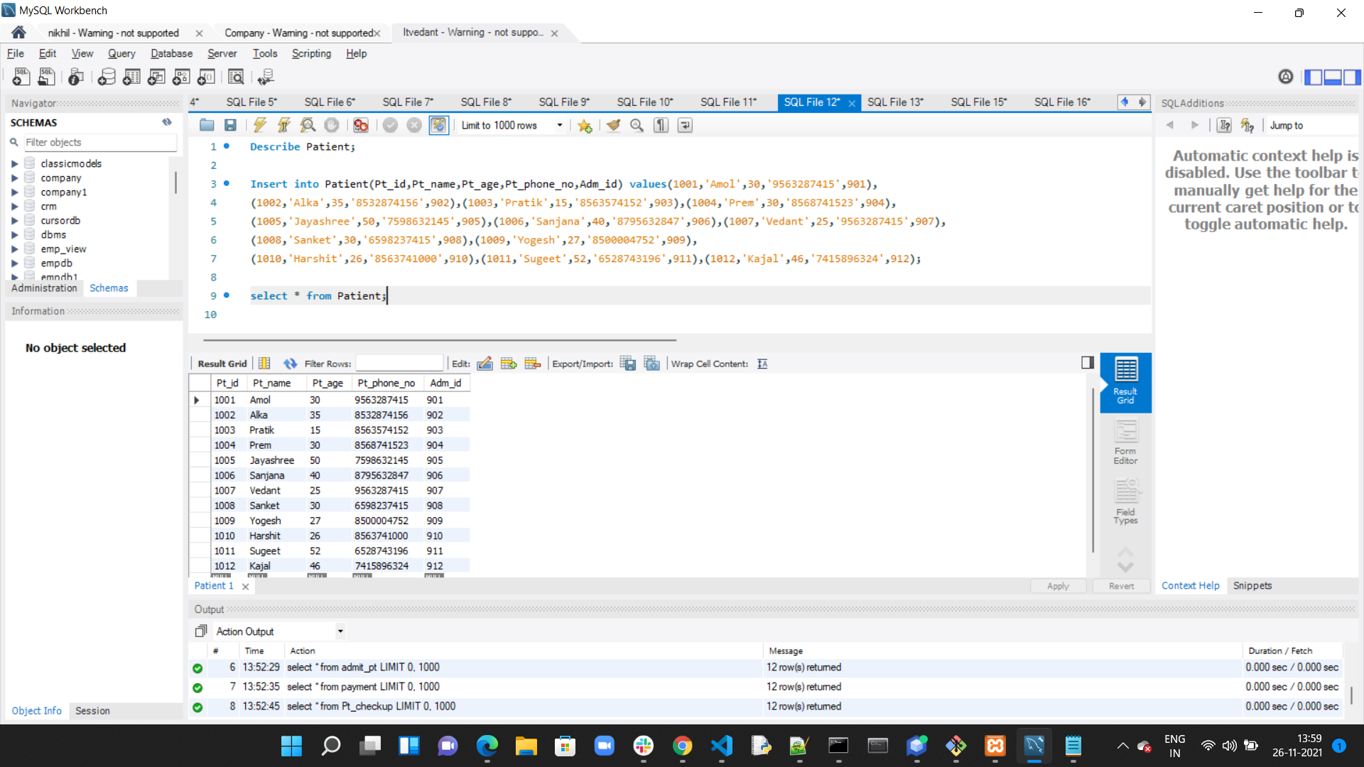

1. **Payment:**

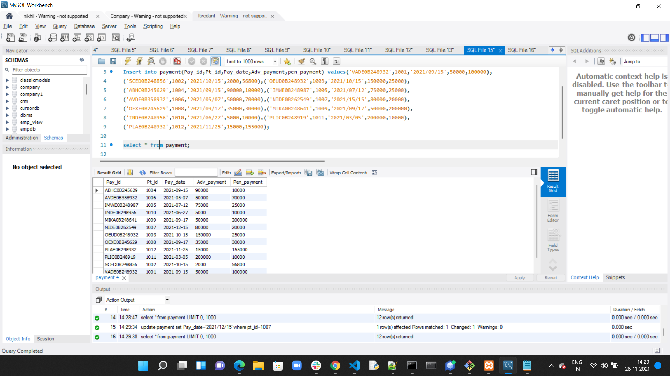

1. **Patient Checkup:**

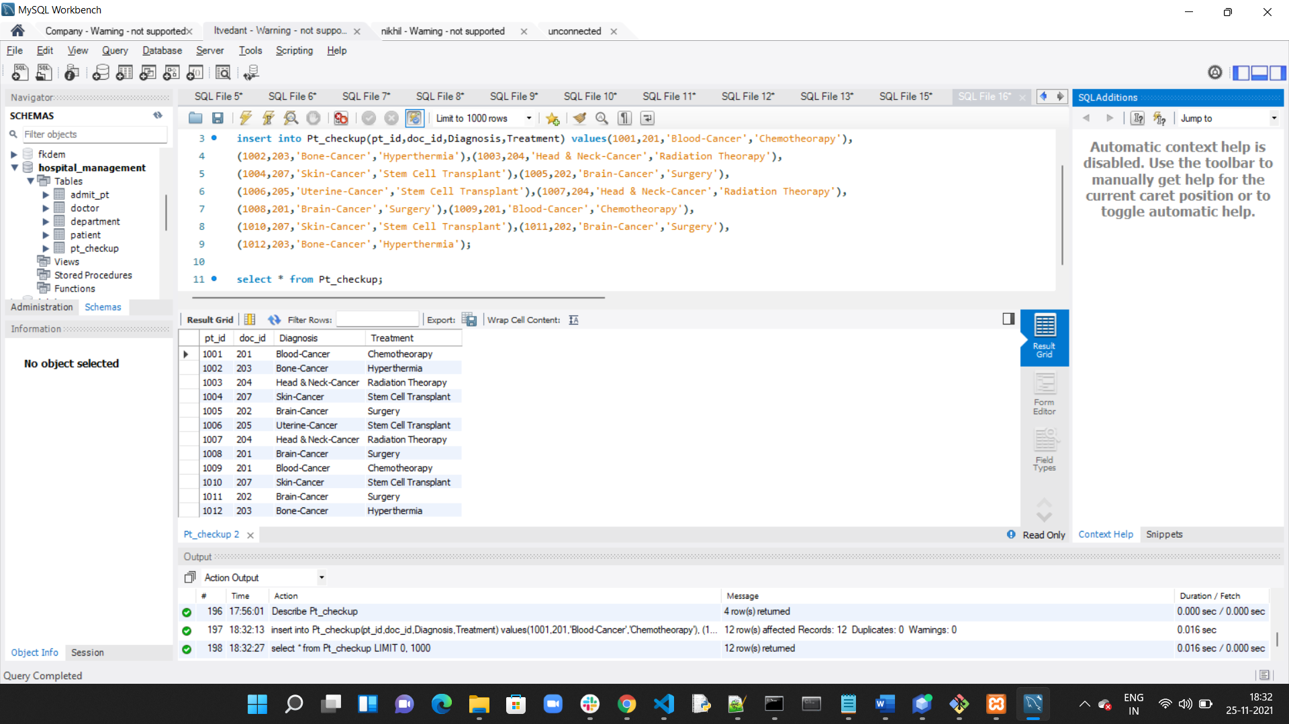

**Adding column by alter statement:**

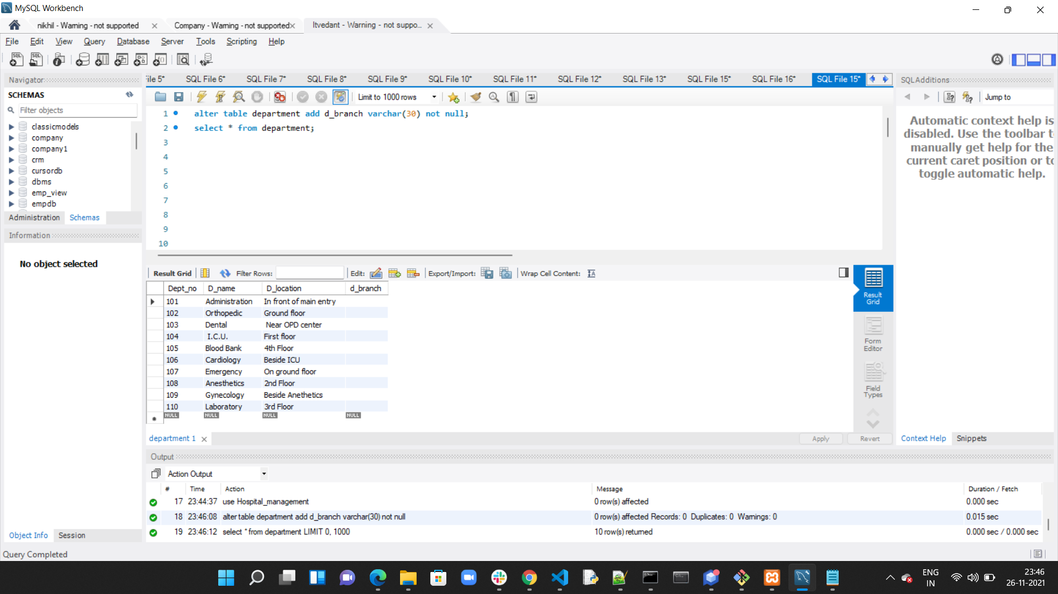

**Change column name by alter table:**

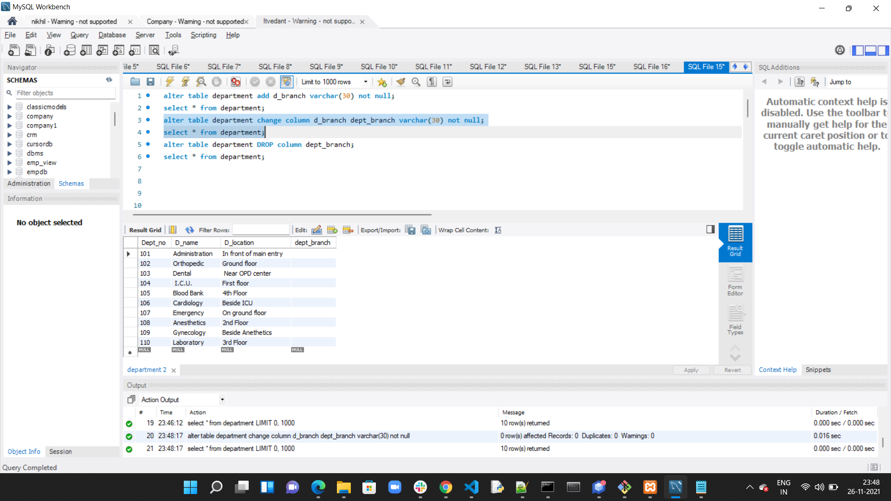

**Drop column name by alter table:**

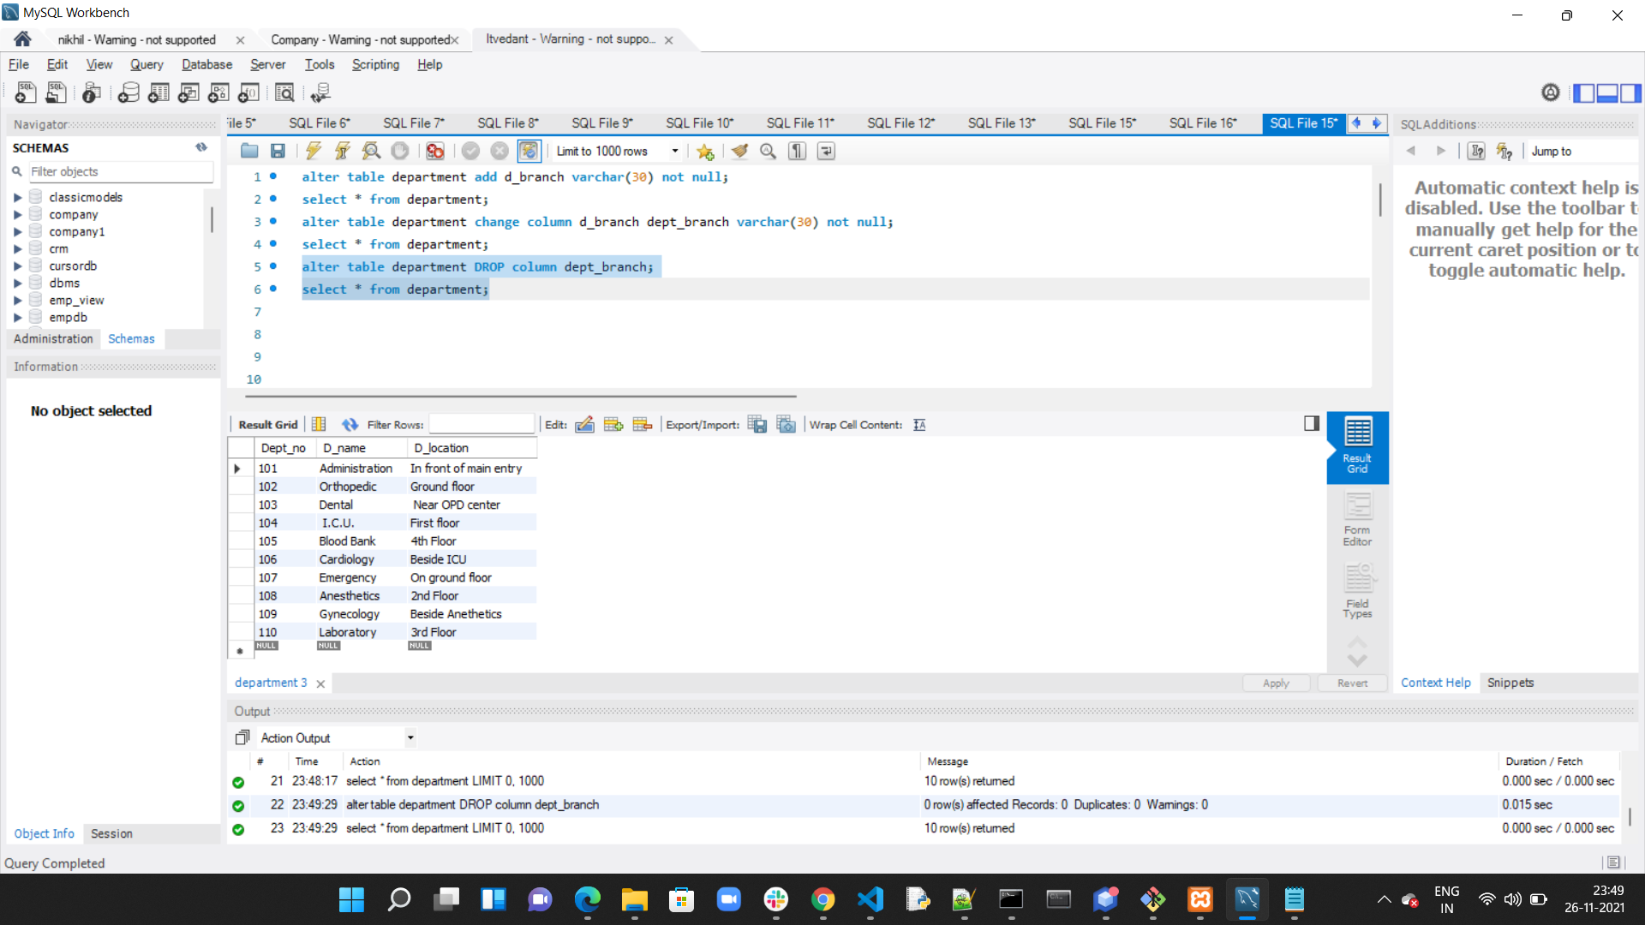

**Changing datatype of column by alter table:**

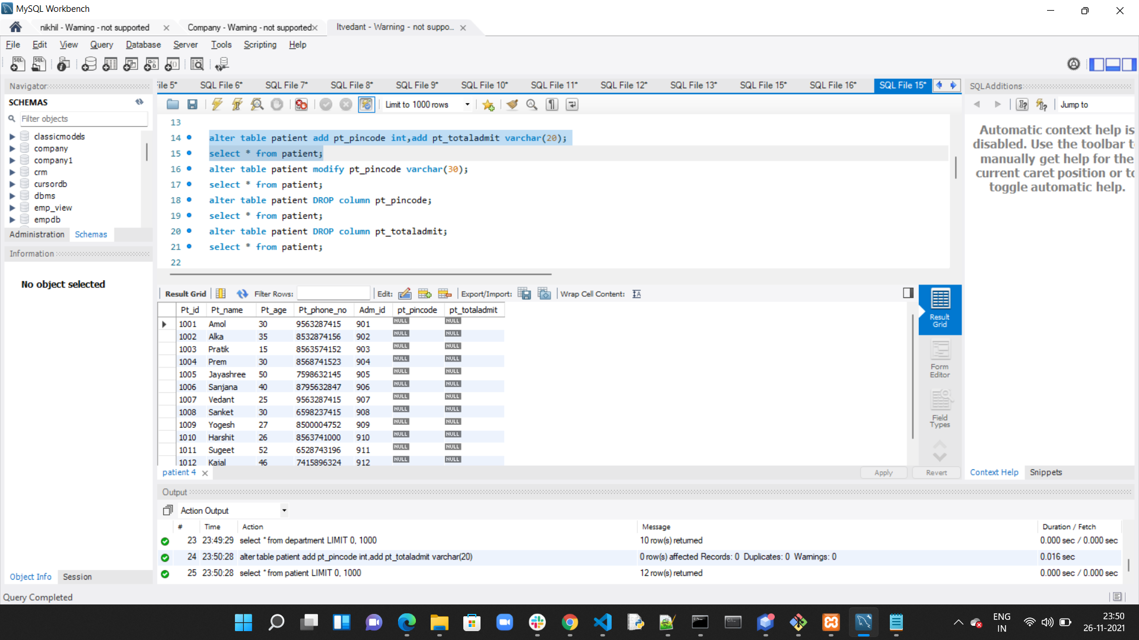

**Modify column by alter table:**

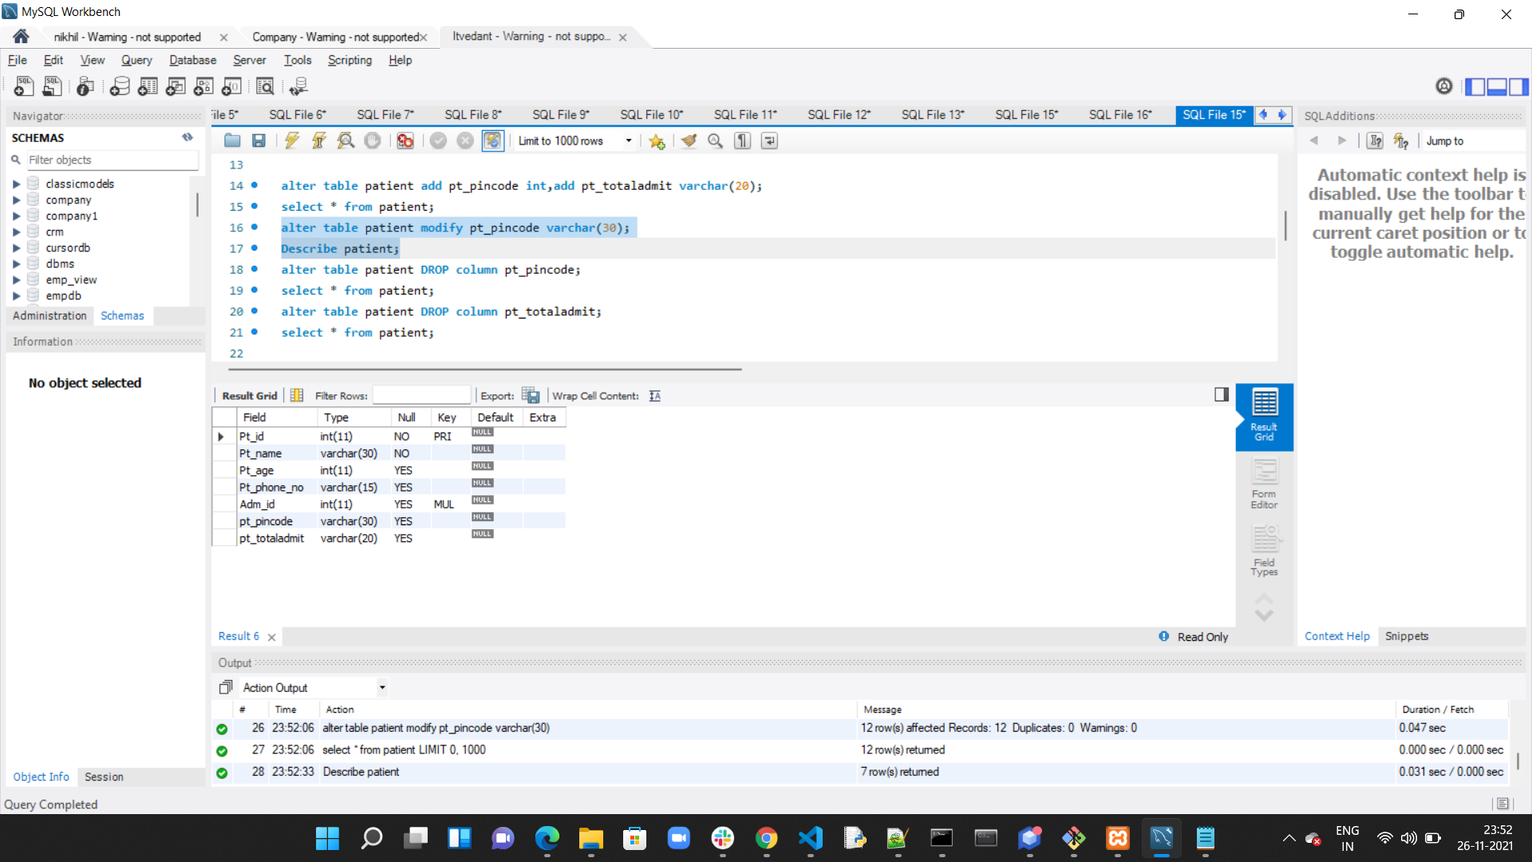

**Drop column by alter statement:**

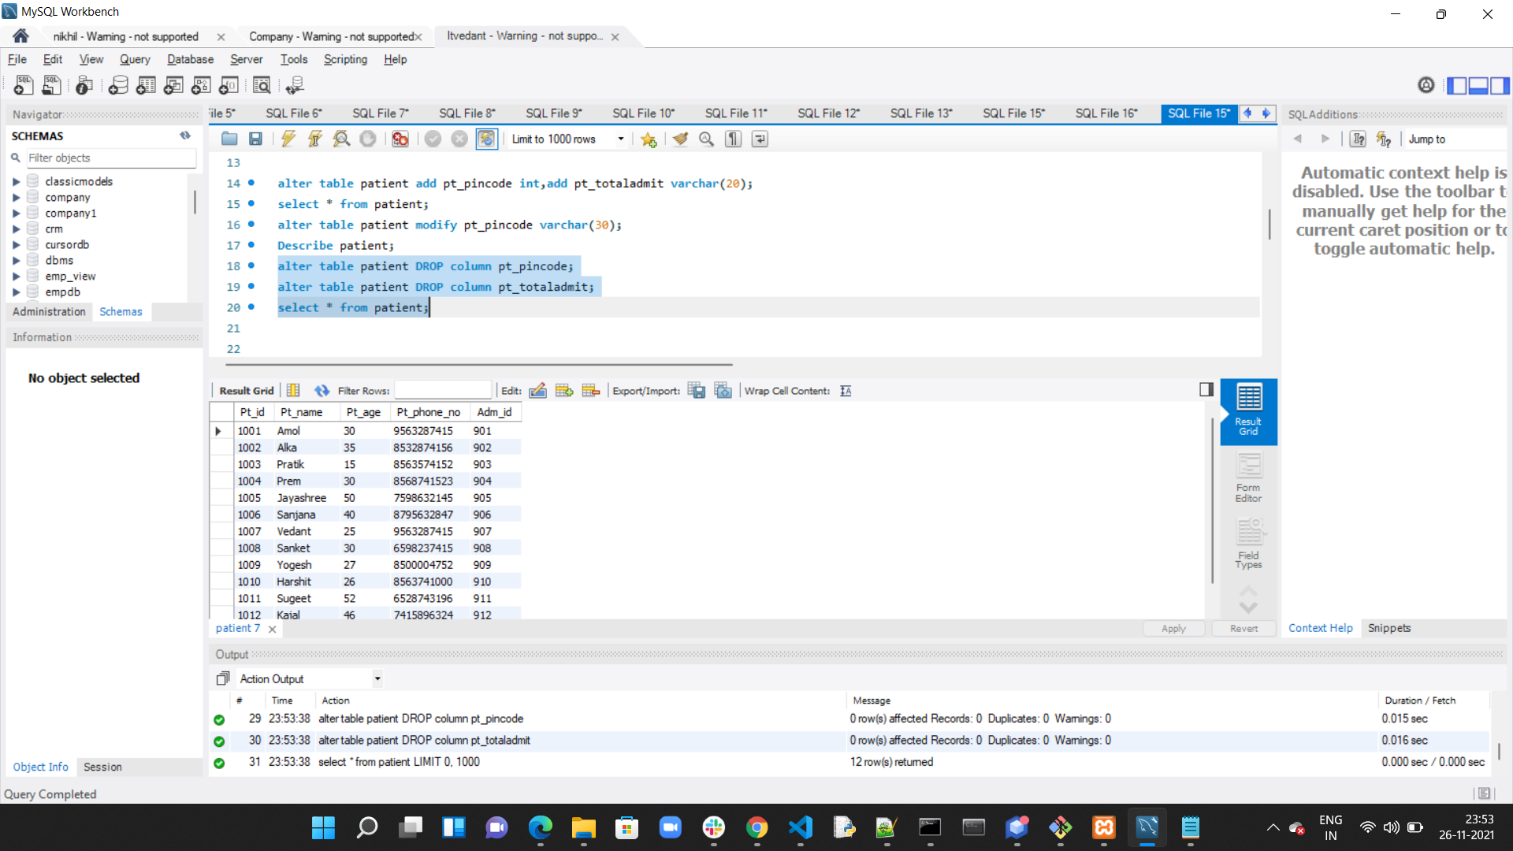

**Updated row by update statement:**

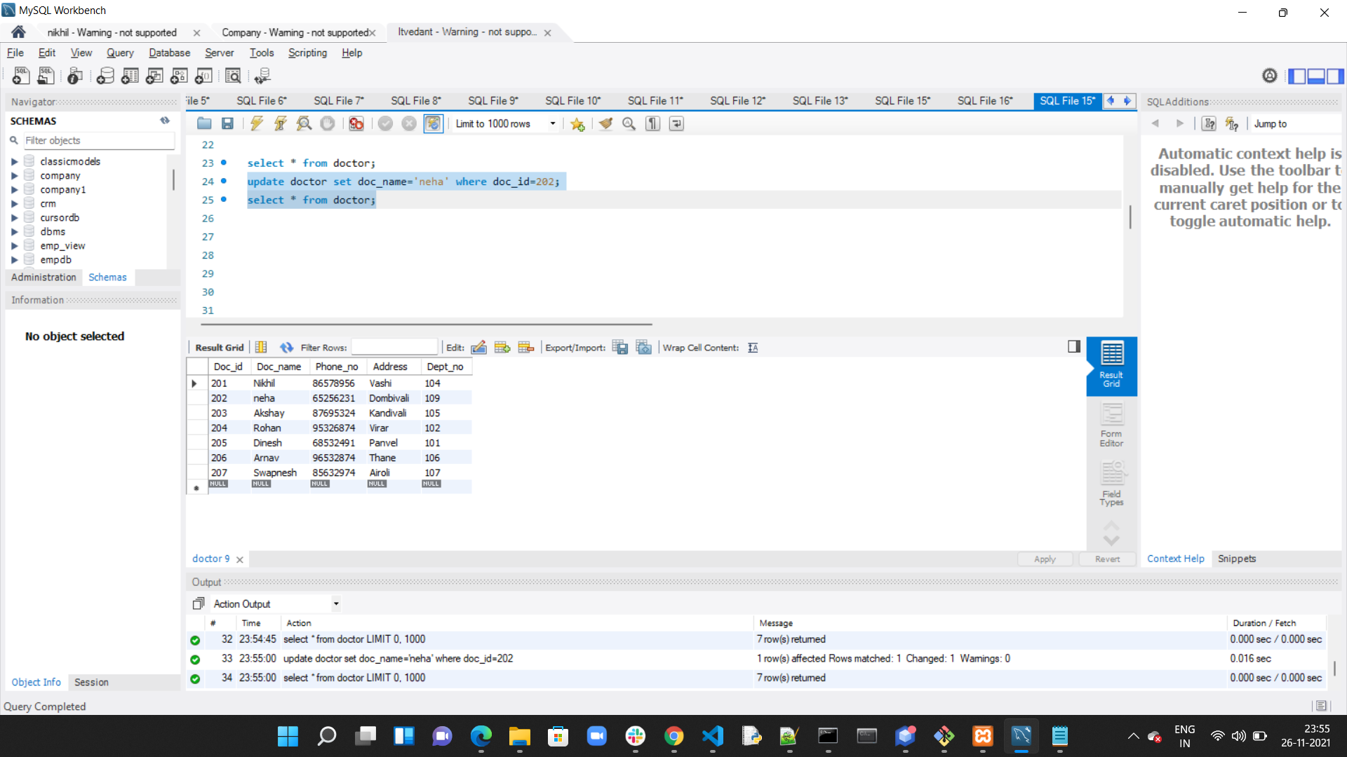

**Aggregate function:**

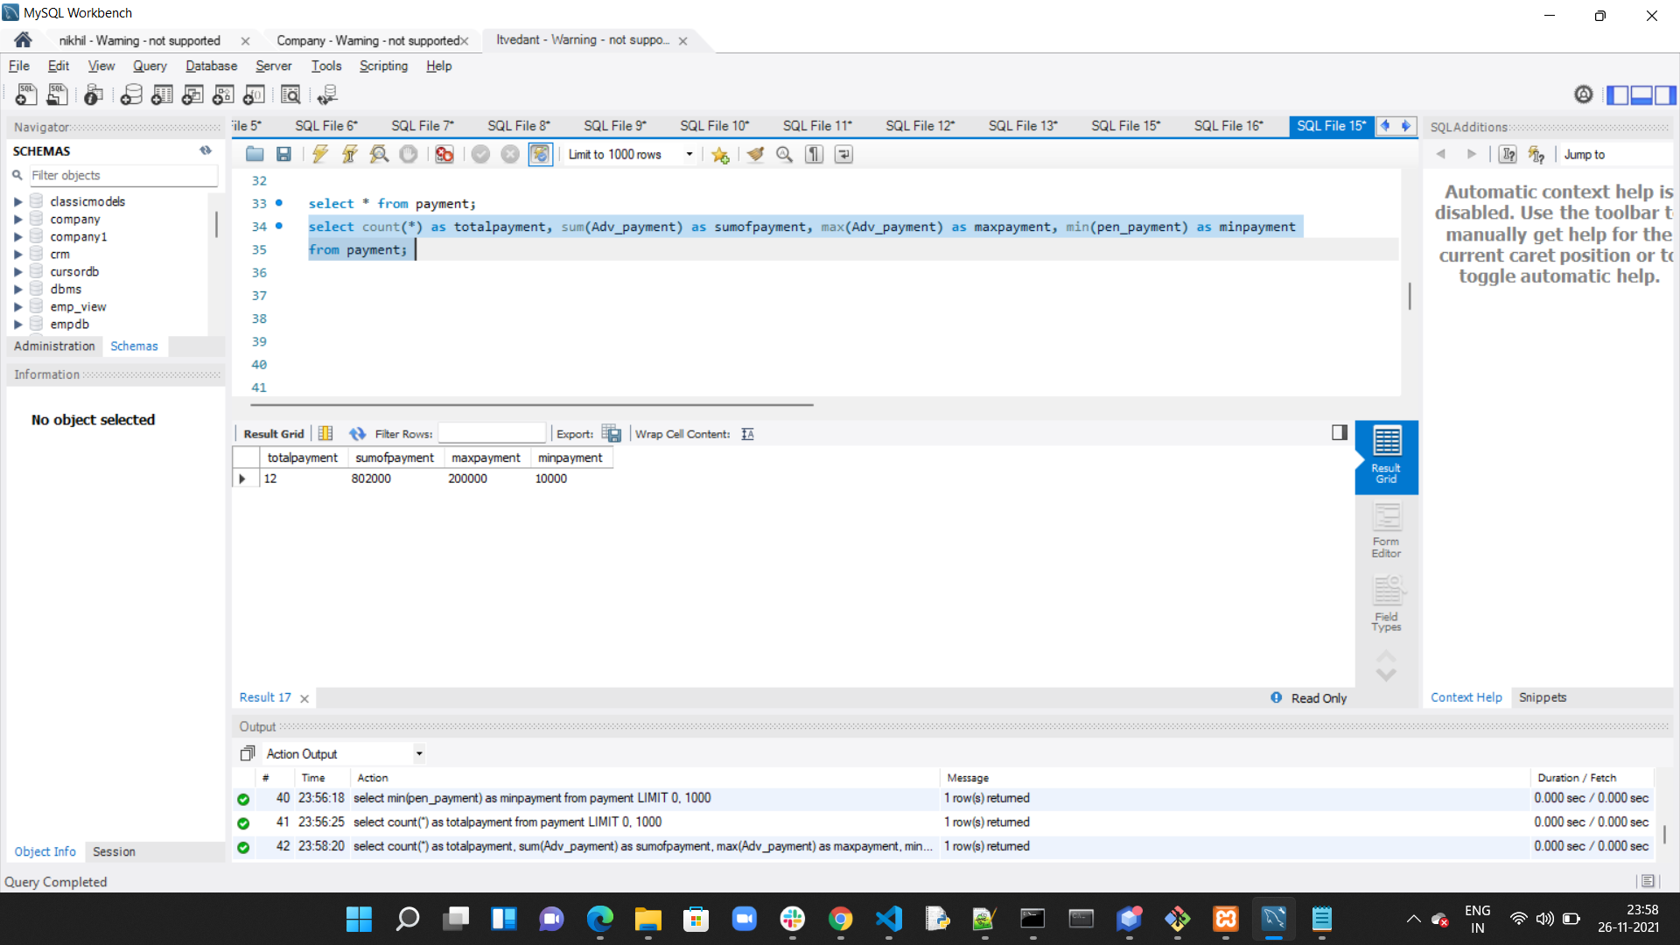

**Like operator:**

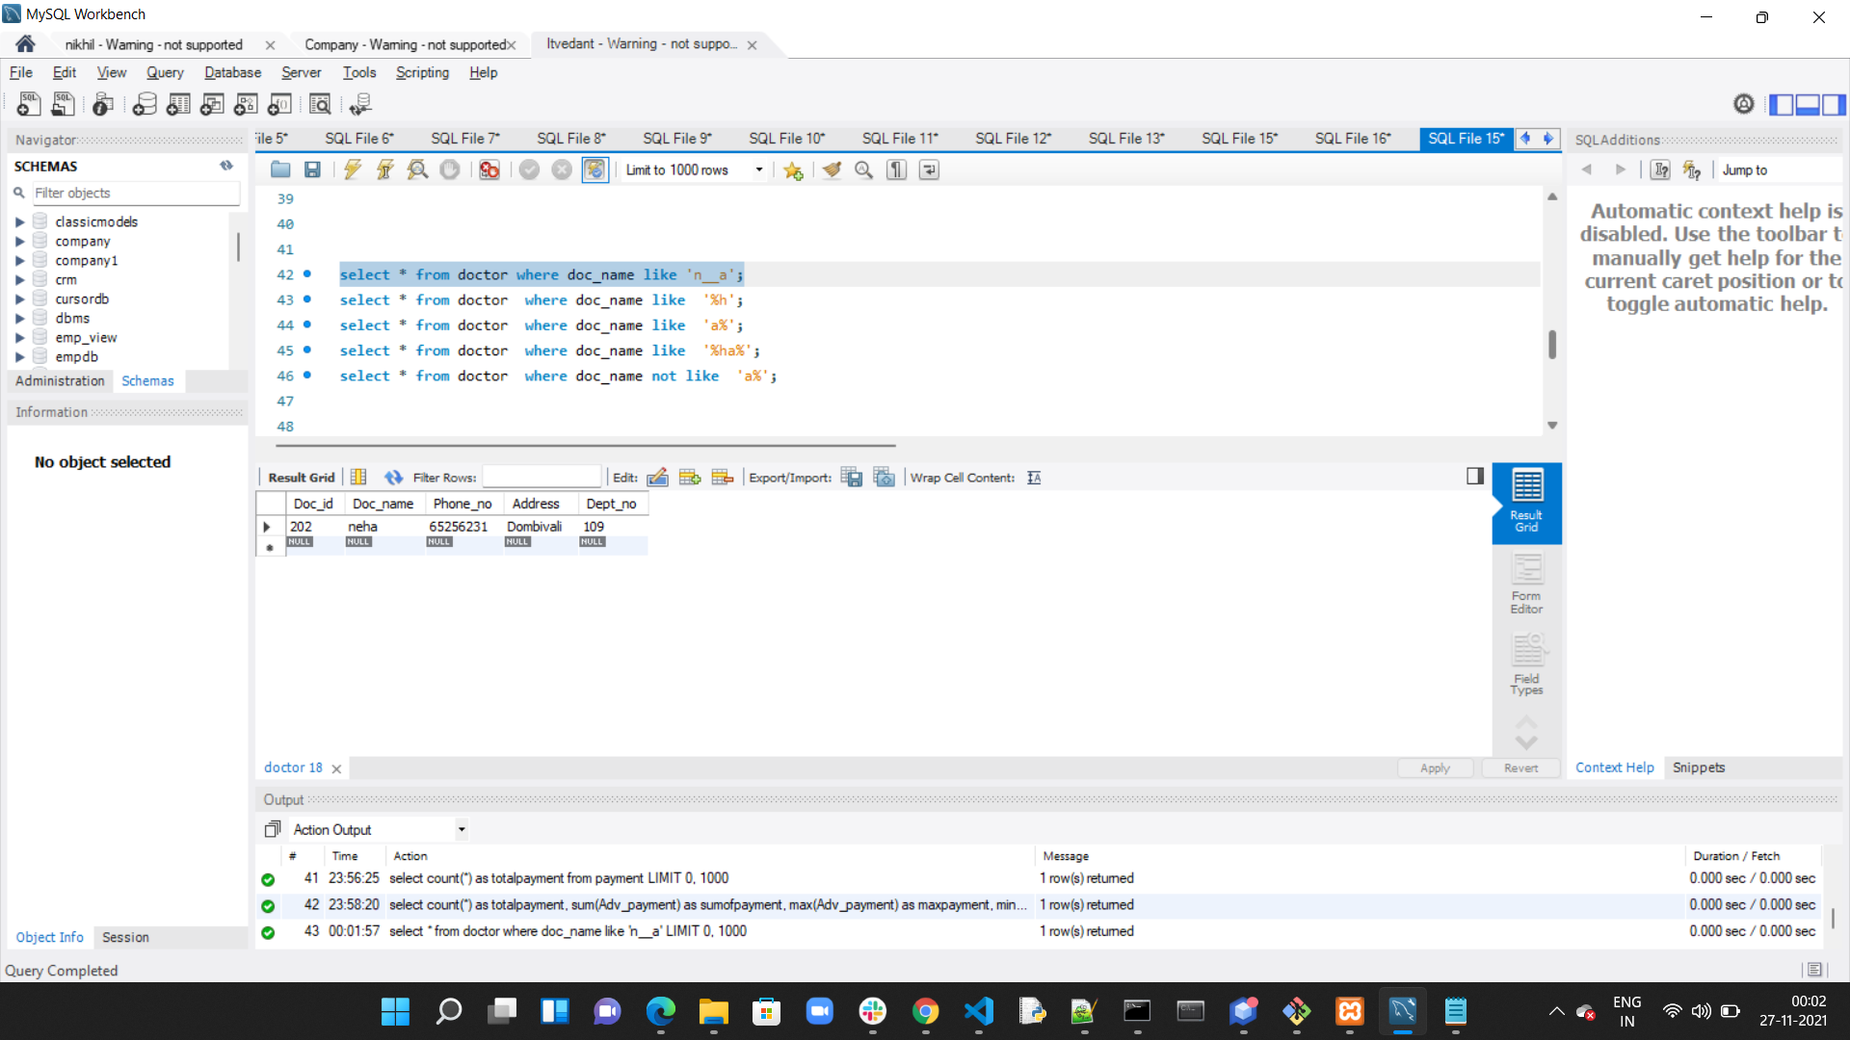

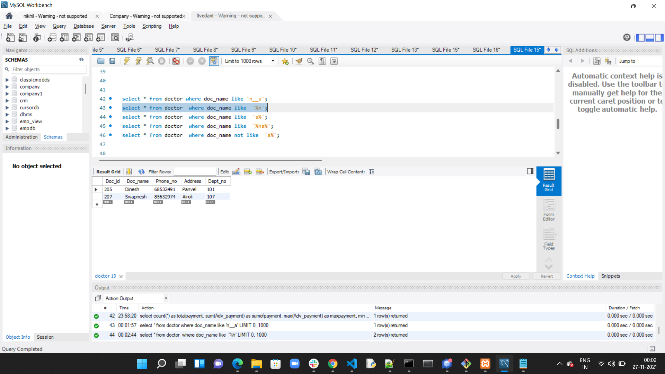

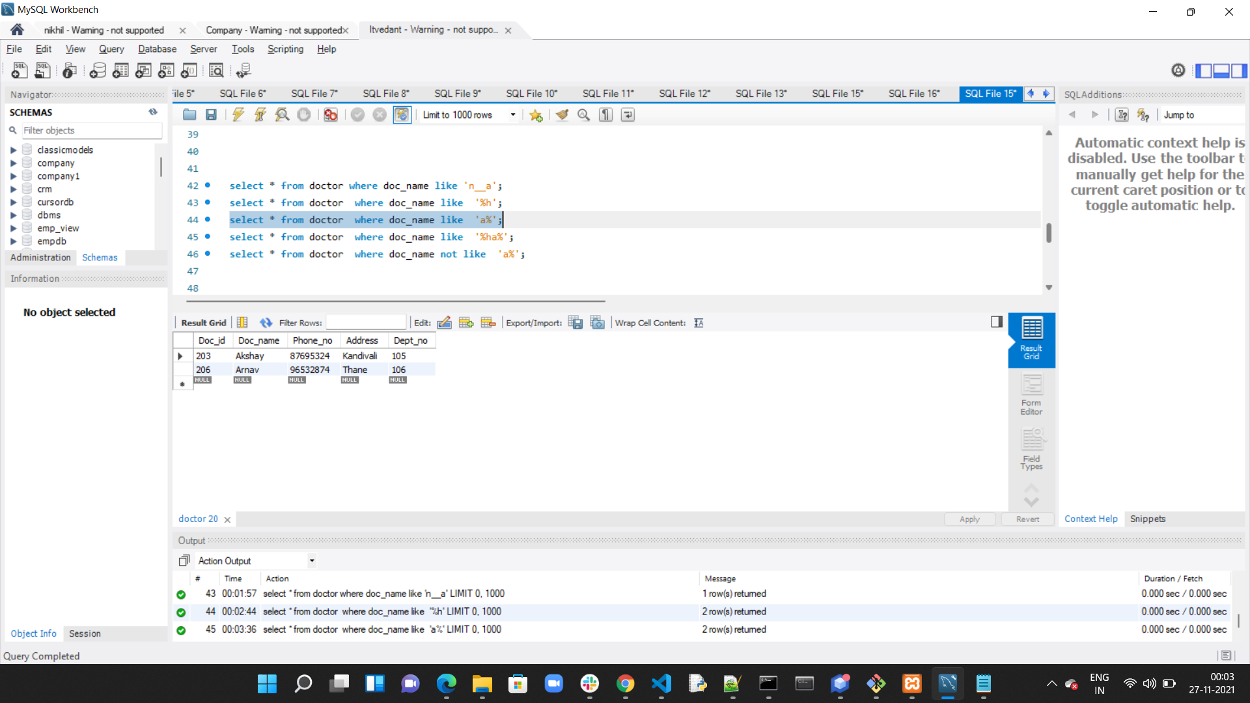

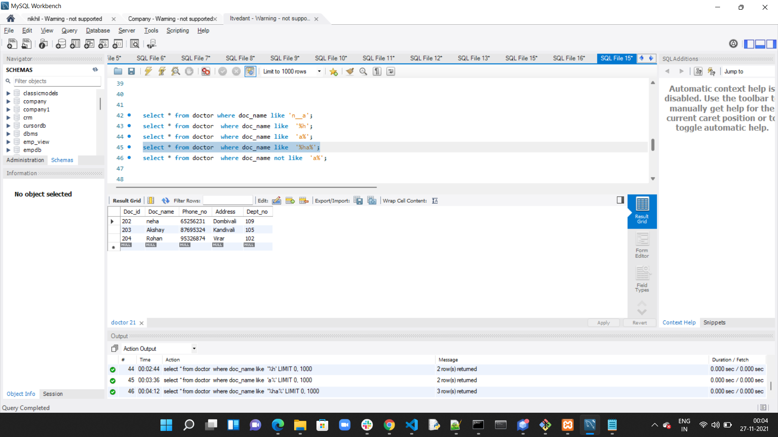

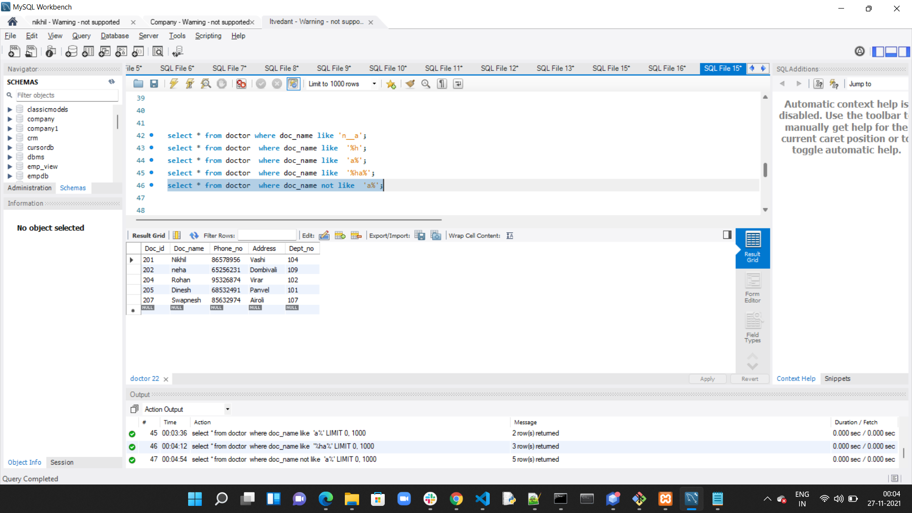

**In operator and between:**

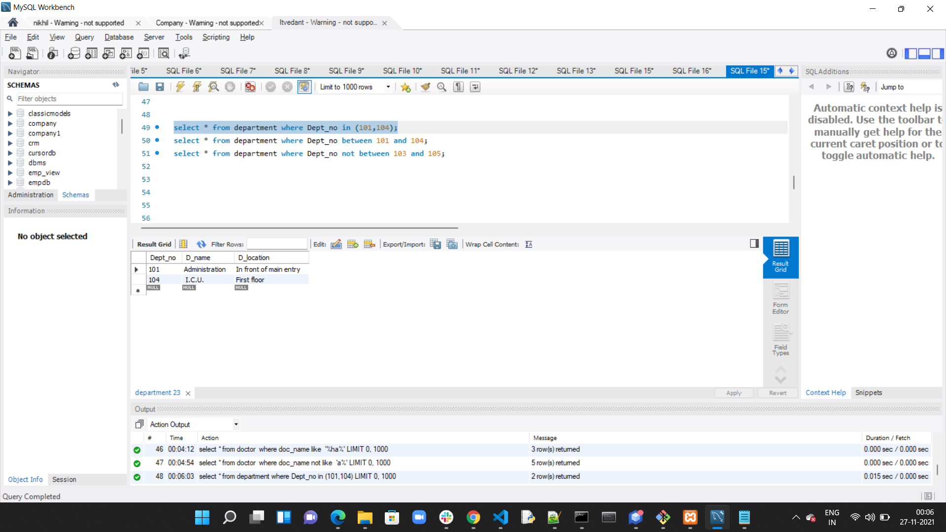

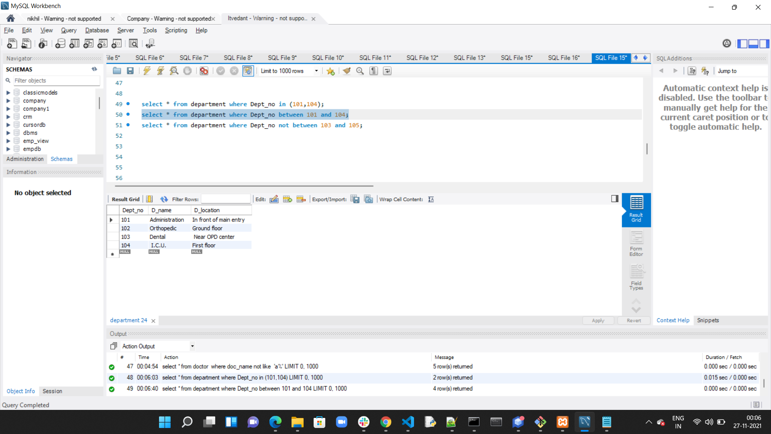

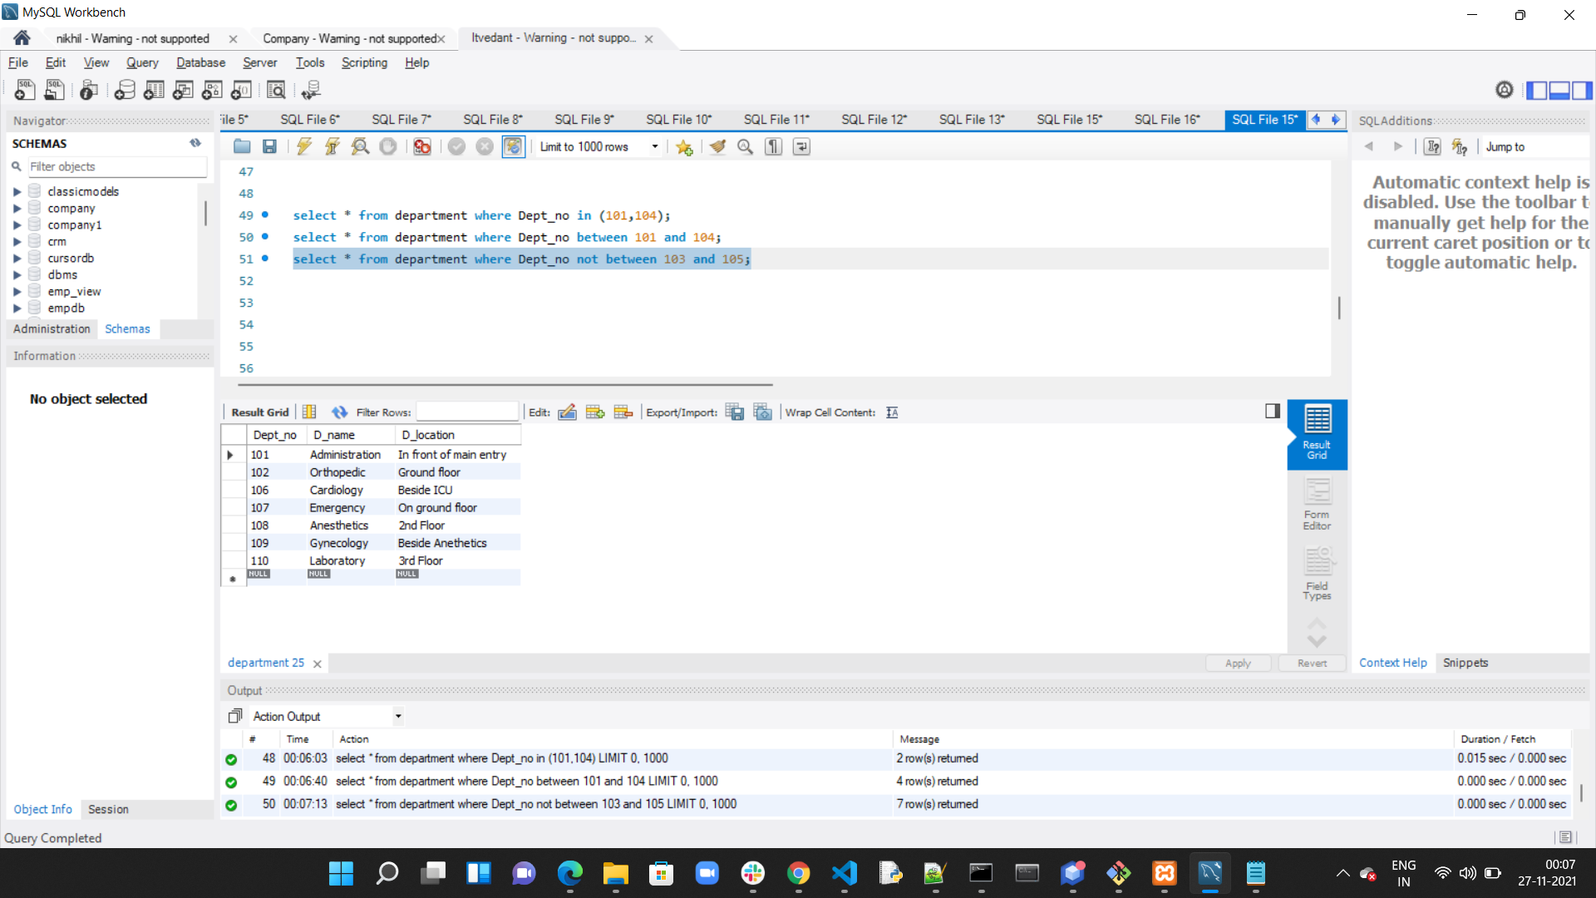

**Order by,Limit,not,<>,Date:**

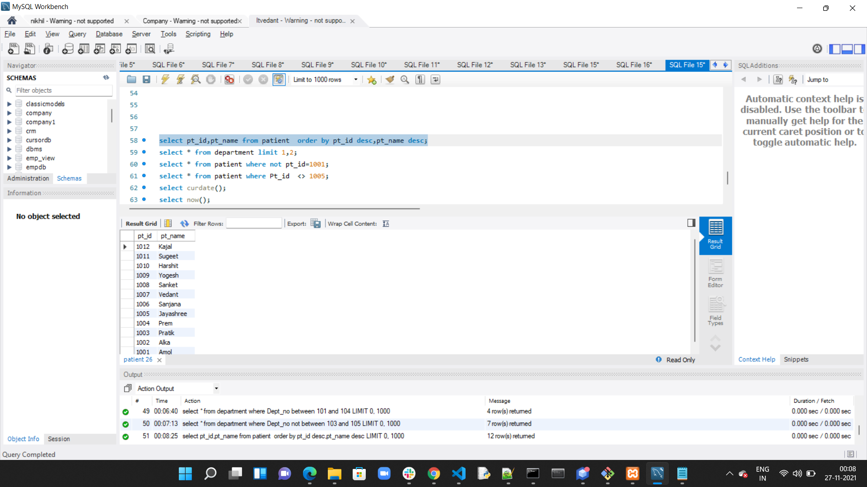

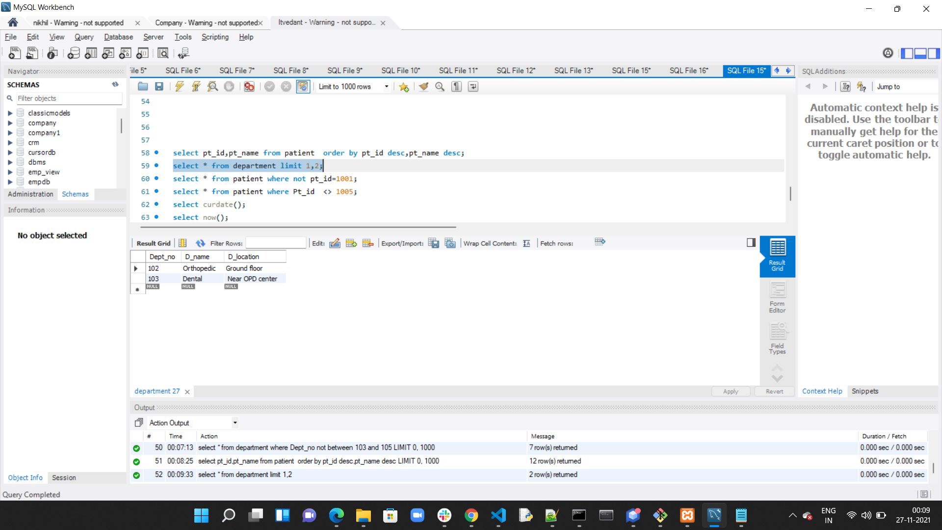

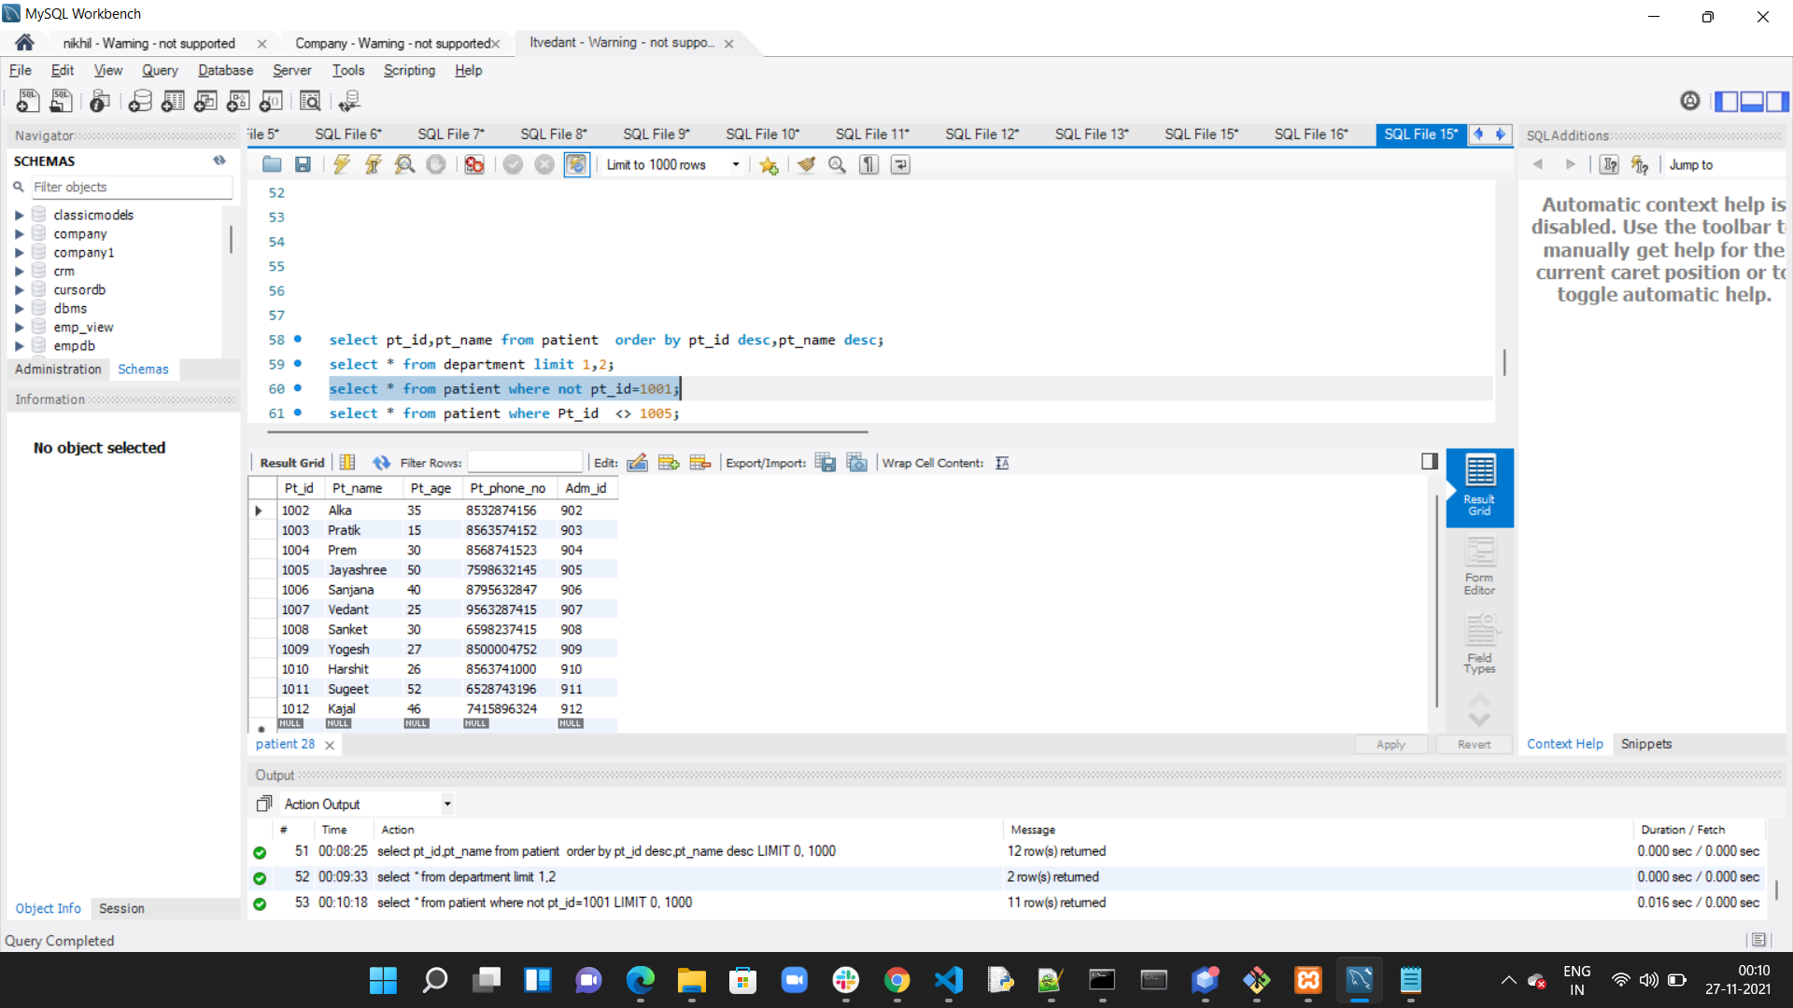

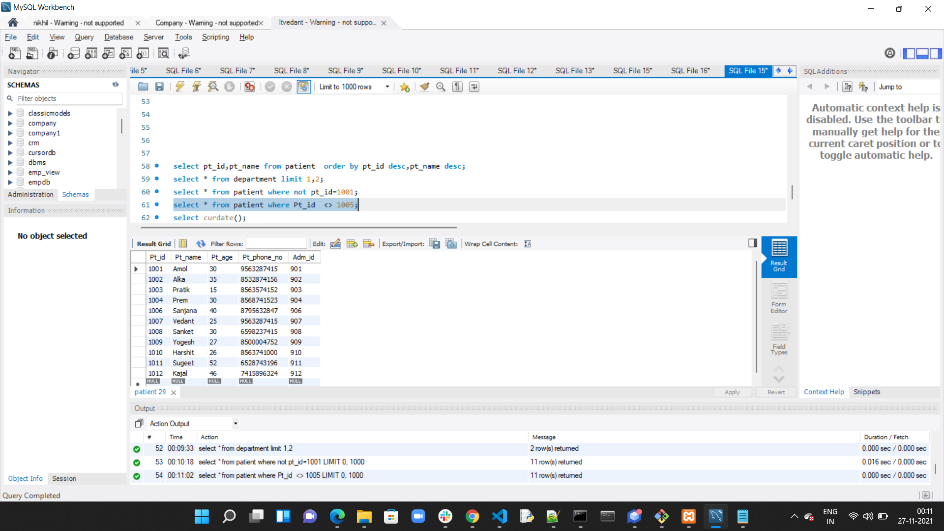

**Date:**

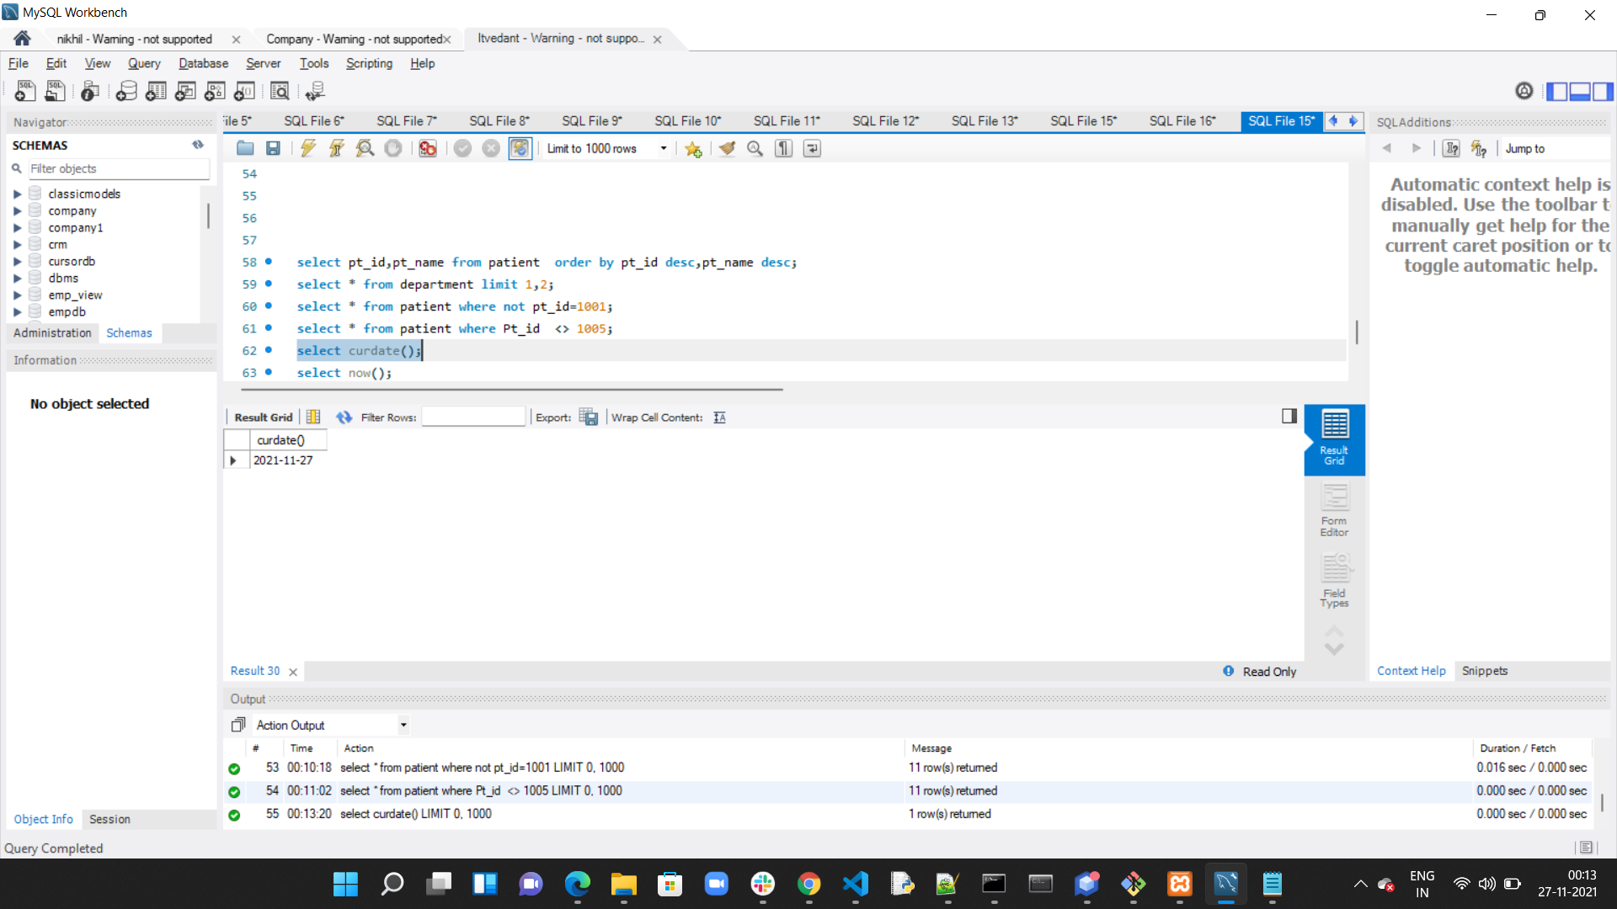

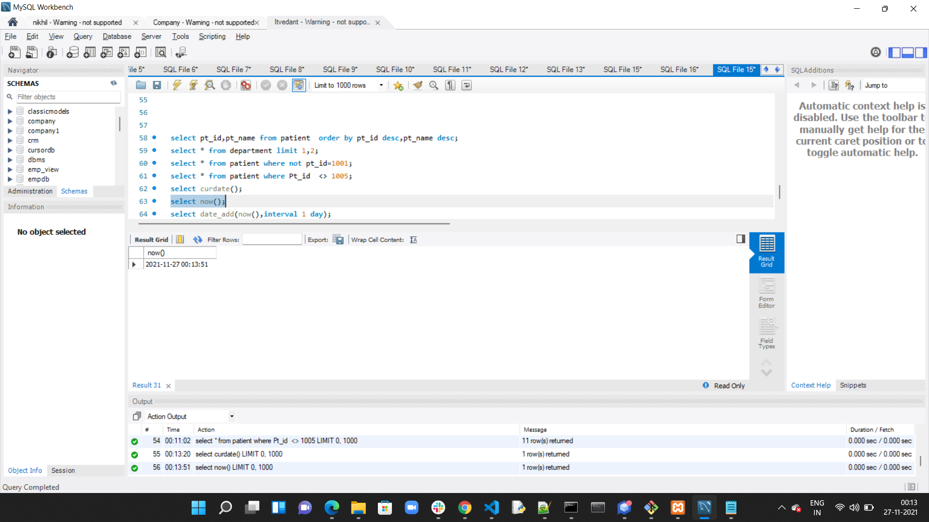

**Date with interval 1 day:**

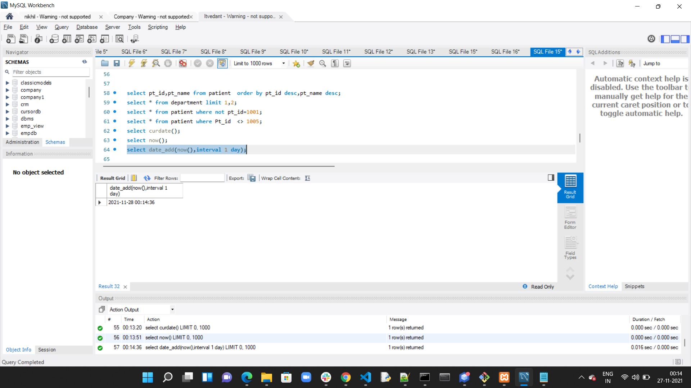

**Date with interval 1 day and time:**

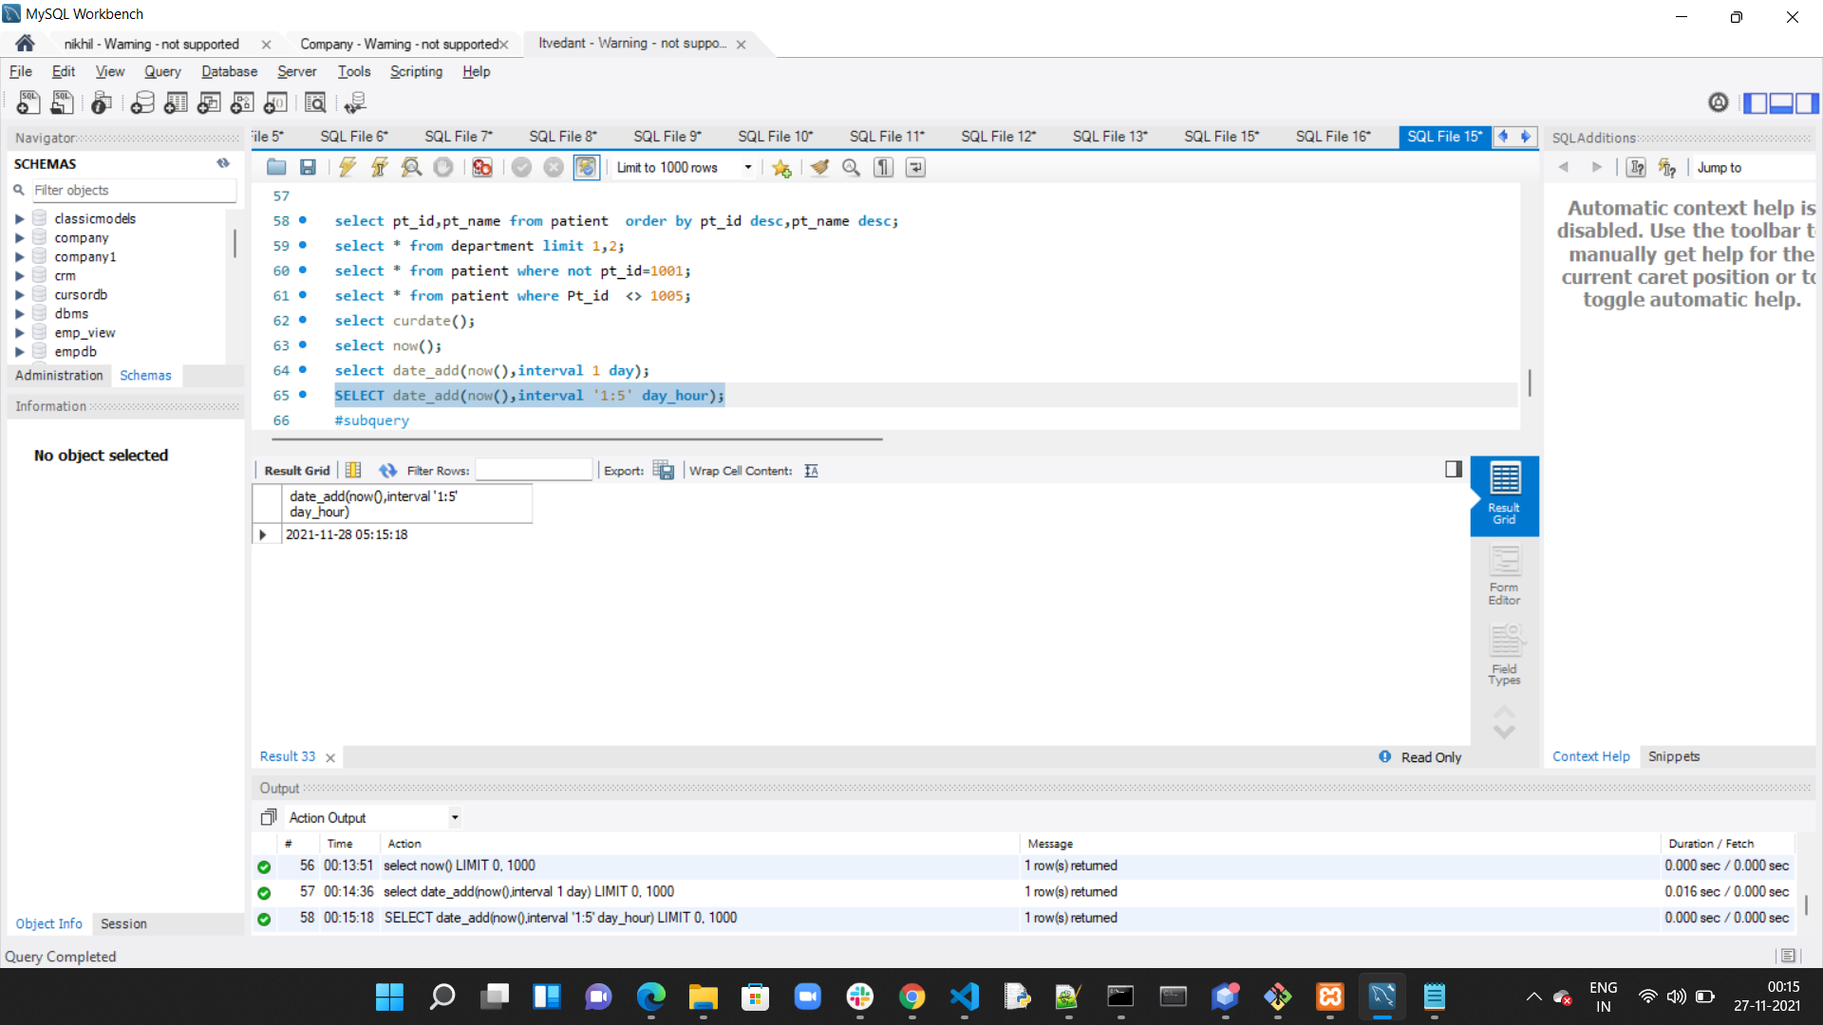

**Subquery:**

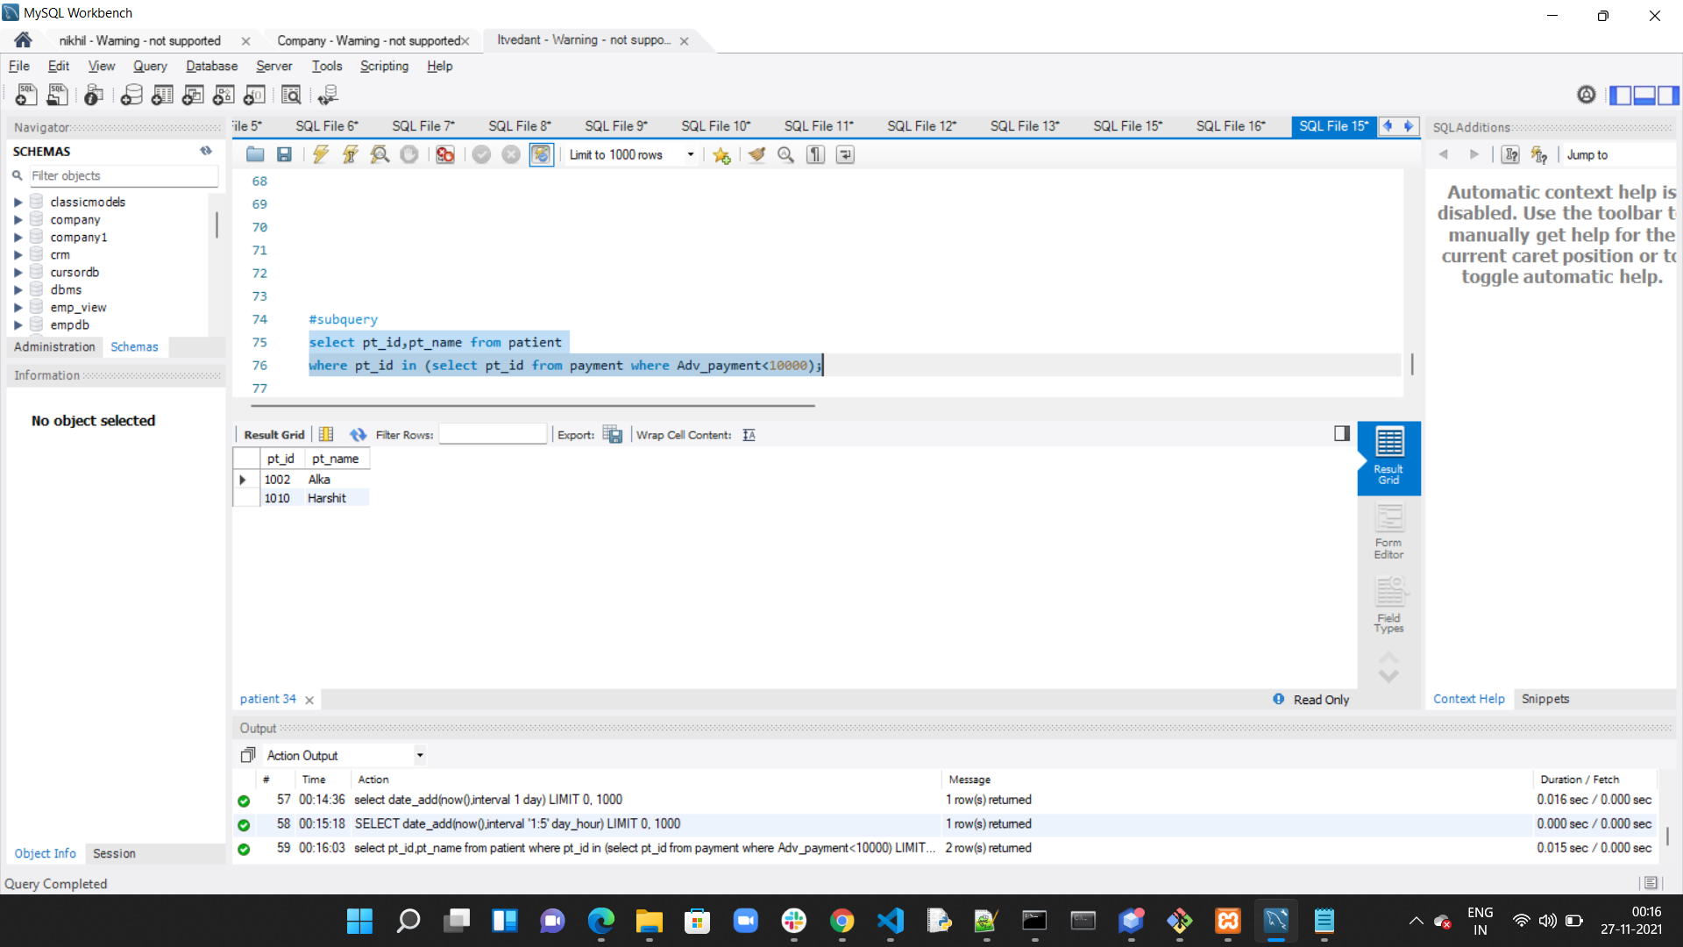

**Grant and Revoke:**

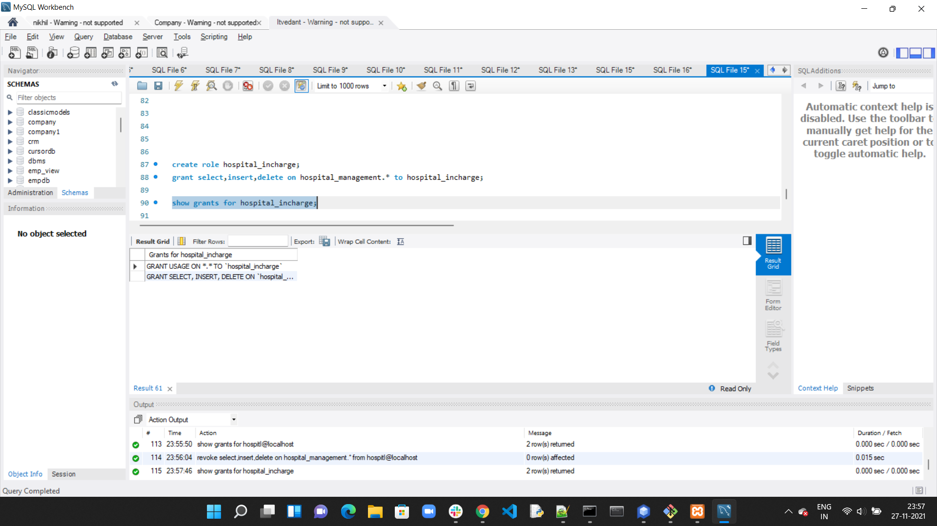

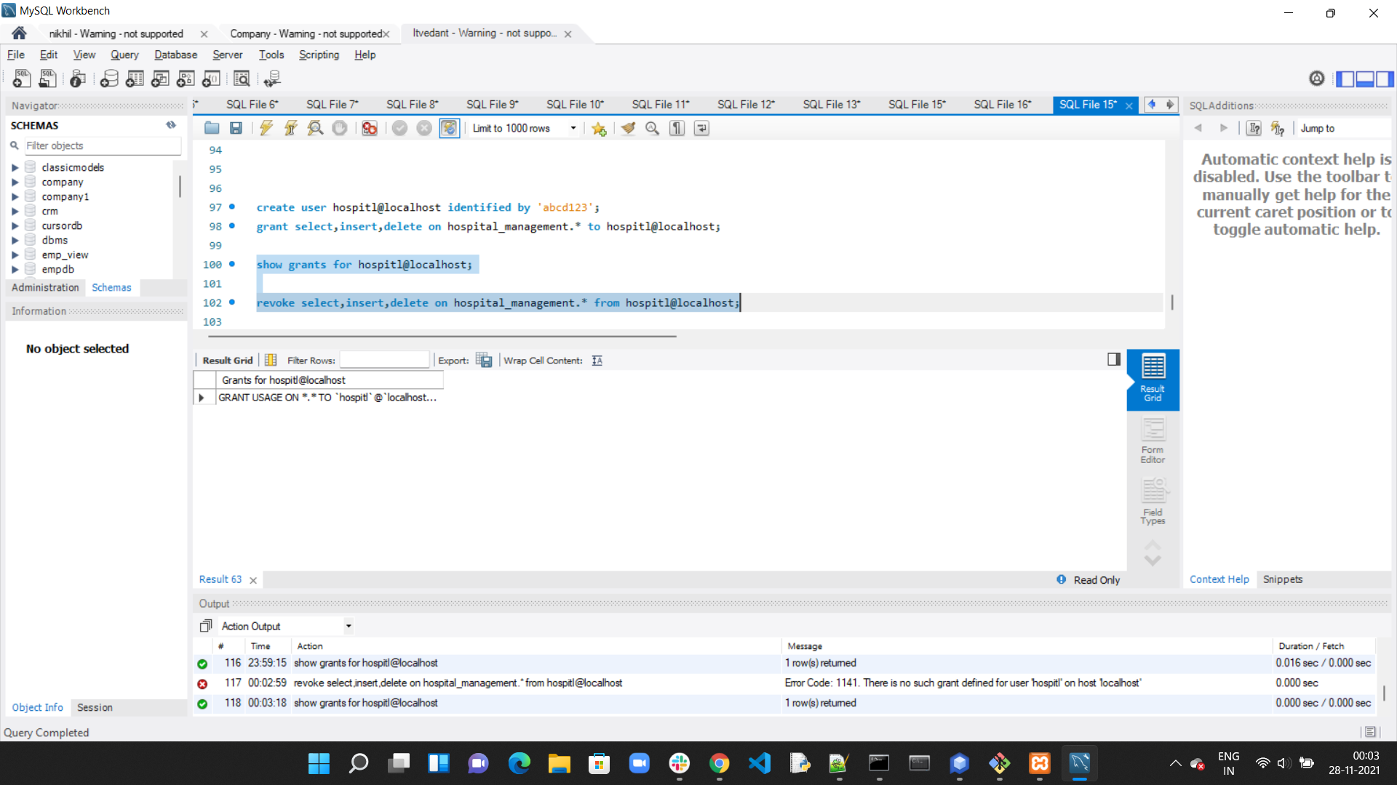

**Joins:**

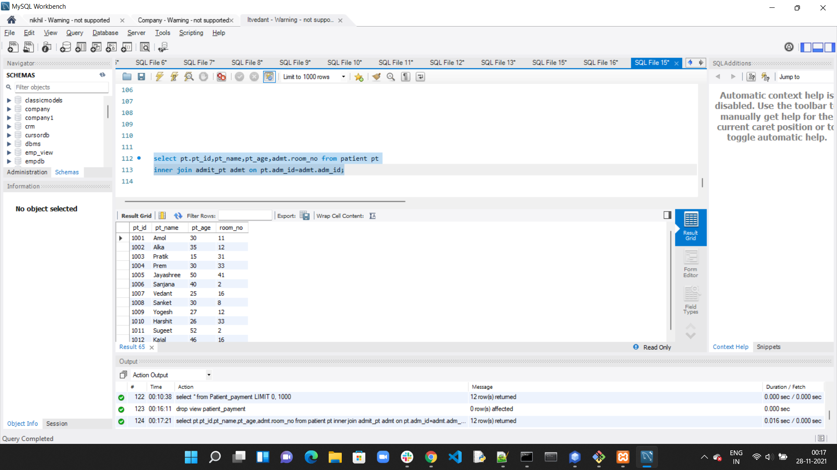

**Views:**

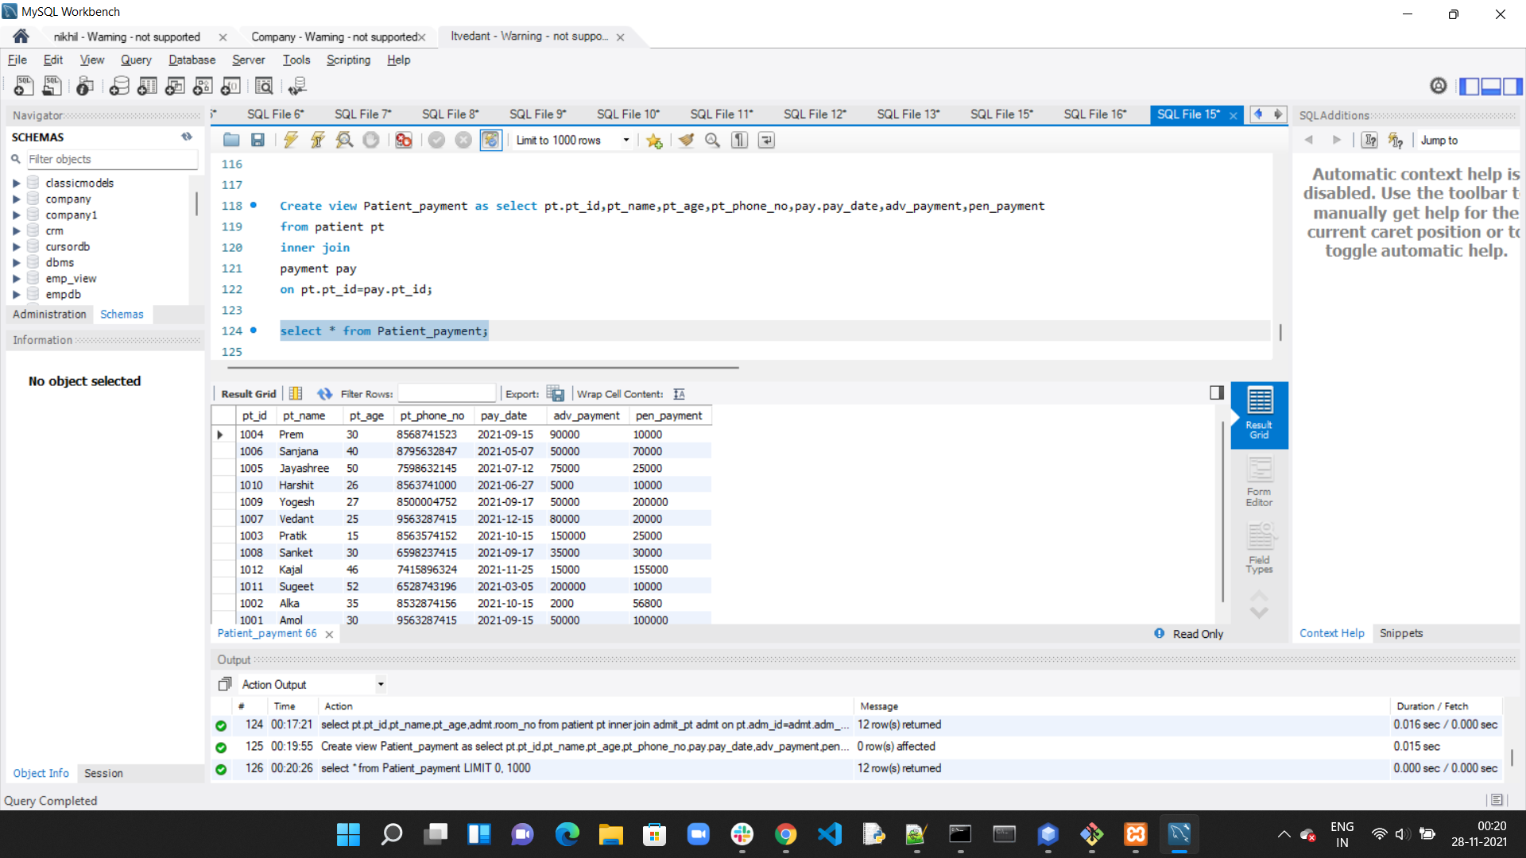

**Stored Procedure:**

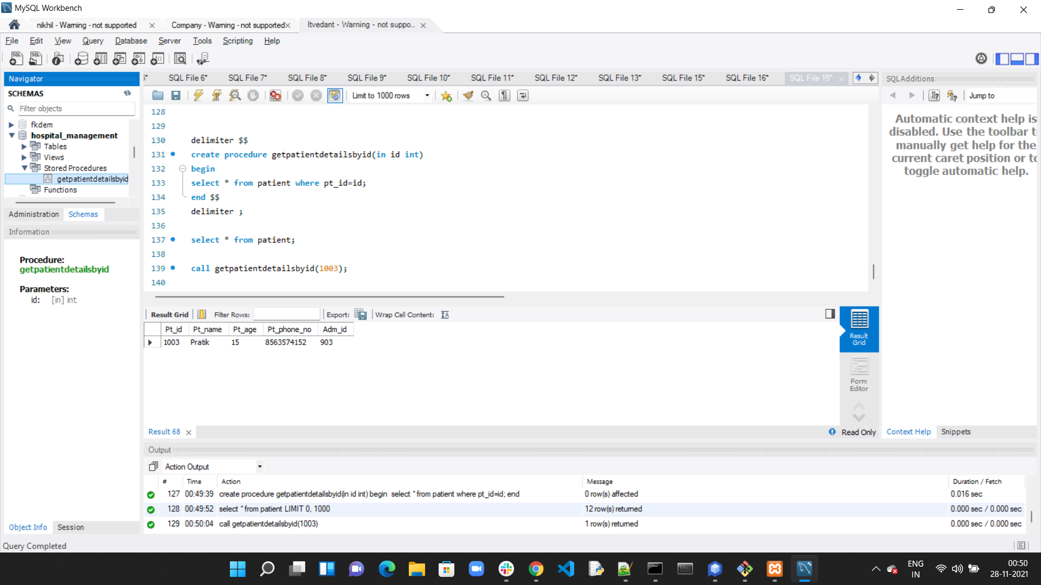

**Stored Function:**

